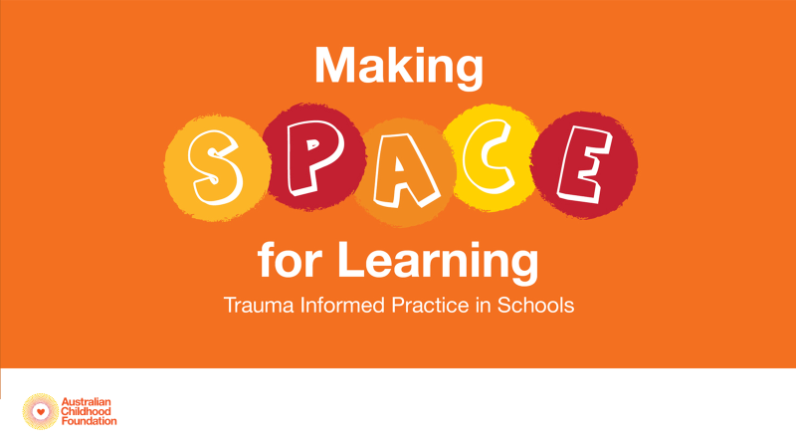
Online Workshop Session Outline 2020

Timing | Slides | Topic/Content | Activities
10.00am | Title, Acknowledgement, Principles | Welcome, Intro to each other, housekeeping (re privacy, zoom etiquette agreement, breaks, resource access, etc), Intro to the session including structure and scope.  Note re participants’ emotional safety & self care.  Background to workshop – outline ACF’s experience working with schools and Ed Depts around the country. Highlight this is a content-based session rather than strategy/practice focused session (can flag other workshops for strategy focus) | Can start the session with a poll for ice breaker/getting to know you.  Small group: can go around the room for people to intro themselves and their role. Large group: can do this via raising hands, chat, poll.
10.20am | Trauma,  Trauma Impacts | Briefly outline trauma definition and various types of trauma. Explain complex/relational and developmental trauma, highlight these as the key focus for the session.
 | Trauma & the brain  Neuronal connections  Neuroplasticity  Developmental stages | Outline key principles re brain development – how connections are formed, neurosequential development, priorities of survival/emotional/thinking, implications of sequential development and hierarchy of priorities in trauma/stress context & school/learning context
 | Brainstem  Cerebellum  Diencephalon  Limbic Lobe  Amygdala  Hippocampus  Cortex/PFC  Medial PFC | Work through each brain area, discussing normative development, core functions, impacts of trauma & options for reparative strategies.  Discuss the role of mindfulness in activating MPfC and regulating subcortical areas + nervous system.  Outline scope of mindful practices & advocate for considered/safe use of activities within context of child’s experience/capacity and worker’s scope of practice (e.g. a word of warning re the use of body mapping). | Pause to practice any simple eg’s as you go through – e.g. rocking from side to side, desktop tapping/drumming, stretching, breathing activities (*can ask participants in advance to bring some items to the session).  Ask for eg’s from the group re what they use in their work.
12.00 | SHORT BREAK – negotiate 10-15 mins |  | Participants & facilitator to mute during break.
12.10pm | Summary slide re brain impacts  Summary slide re strategies | Brief review of key points from previous section.  Can offer to send these slides in full page format (saved as a handout in K: & Sharepoint)
12.20pm | Left/Right Hemispheres  Adolescent Brain | Outline key messages re:  -functions of left and right hemispheres  -role of corpus callosum  -impact of trauma on CC, L-R functioning & integration  Explain the role of repeated/practiced midline crossing activities & how these can be integrated simply into daily routines.  Briefly outline key principles of adolescent brain development re PfC pruning/myelination, considerations re sleep, safe risk taking, etc + impacts of trauma on adol. Brain. | Explore examples from the group re midline crossing activities. Try some! E.g. patting head/rubbing stomach…
12.30pm | Trauma & the Body  PVT  Window of Tolerance | Neuroception, cues of risk and safety  Intro to PVT, overview of implications for trauma on nervous system.  Eg.s of what social engagement, mobilised & immobilised responses might look like in a school setting.  Intro to WoT & concept of regulated/dysregulated arousal.  Goals: support children to remain in/return to the WoT + support children to titrate/expand their WoT | Discussion/reflection on personal WoTs, what does it feel like to be outside our Window? What do we notice? What do we do to re-calibrate?
1.00pm | Trauma & Behaviour | Describe trauma-informed lens re framing behaviour: key principles re understanding behaviour as functional & adaptive, describe e.g’s of adaptive survival responses in dangerous home environment & what these might look like when transferred to the school setting.  Work through the points on “framing behaviour support plans” slide as a framework for considering how to respond to challenging behaviours. | Offer e.g’s of behaviours & responses for each point.  Invite e.g’s from the group. If time, participants may offer e.g’s of behaviours which can be “workshopped” by the group to brainstorm responses that meet the need/build a capacity/restore safety/reduce triggers, etc
1.20pm | Multi-tiered service  SPACE acronym  SPACE Audit tool  Showcase Booklets | Briefly outline the need to develop strategies and interventions across all levels (NB this structure aligns with the Positive Behaviour Support framework used by many Ed Depts). If time, can give e.g’s of intervention at each level.  Plug showcase booklets as a resource for ideas on a variety of trauma-informed approaches implemented and evaluated by schools in various states. | Ensure participants have accessed the booklet through learner portal. Refer to relevant section of booklets for participants to review in their own time.
1.30pm | Session End | Check for last burning questions/comments.  Thank the group for participation and engagement.  Confirm any resources to be forwarded after the session.  Final word of encouragement re the efficacy of trauma-responsive practices in education. | Use the last few minutes to reflect on key learnings or salient points from the session. Can either go around the group and take turns to comment, or can ask for comments/key words/reflections in the chat (depending on group size and time left)

