# Neuroscience of feedback

David Rock CEO Neuroleadership Institute

Beth Jones Neuroleadership Institute

Not too long ago, 62 employees at a major consultancy found themselves getting called into a room in pairs, neither person having any prior relationship to the other, for what they were told was a role-playing exercise. Researchers asked them to sit across from each other. Participants then learned they weren’t assigned to be collaborators, but adversaries — opposing sides engaging in a mock negotiation to buy or sell a biotechnology plant. They had six minutes to haggle over the price, and heart-rate monitors would track the ups and downs of the argument.

When the negotiations were finished, each side gave feedback about his or her opponent’s performance. Some participants were told to give the feedback unprompted. Others were instructed to ask for feedback. Quietly, the heart-rate monitors listened.

Here’s what the researchers found: If you want to put people on edge, tell them they will receive some feedback. Or, just as bad, tell them they'll be *giving* feedback. Subjects in the study felt equally anxious offering feedback and receiving it, which might explain why so much workplace feedback amounts to a series of polite statements, with few suggestions for improvement.

[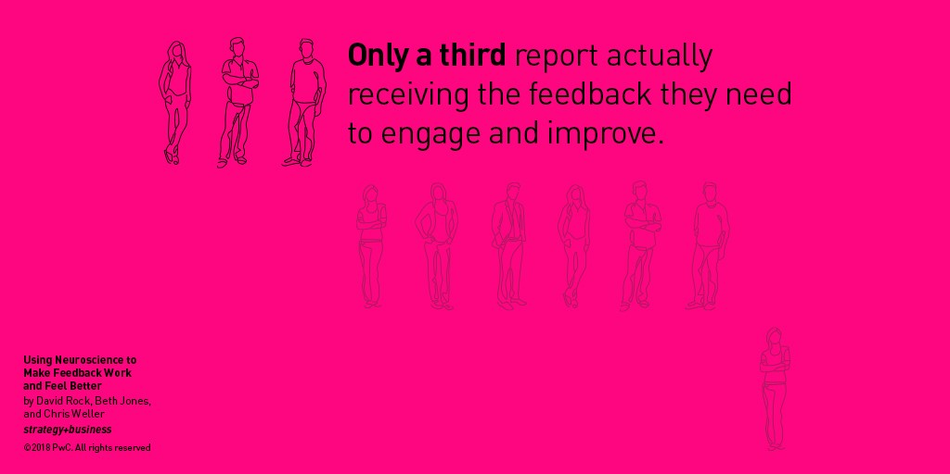](https://www.gallup.com/workplace/236450/managers-millennials-feedback-won-ask.aspx)[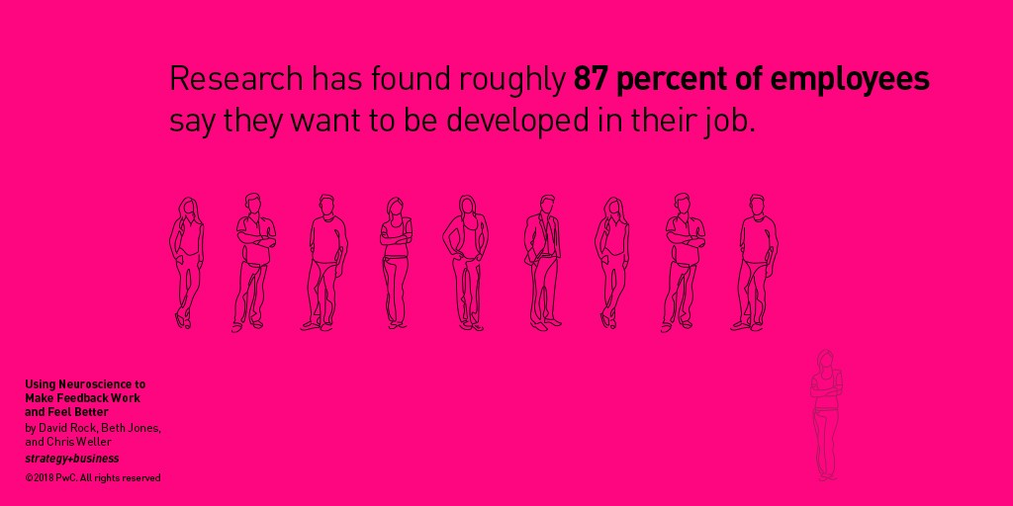](https://www.globoforce.com/press-releases-archive/globoforce-reveals-2011-workforce-mood-tracker-survey-results/)

There’s a strong culture of being very nice to people, and it’s hard to be critical of someone in those conditions,” says Tessa West, the New York University psychologist and NeuroLeadership Institute senior scientist who led the [study](https://membership.neuroleadership.com/material/asked-for-vs-unasked-for-feedback-an-experimental-study/), alongside researcher Katherine Thorson, also of NYU. “How good is the feedback going to be if the person feels this strong normative pressure to be nice during the interaction? It might just be overly nice and not constructive because they feel weird about the feedback experience.”

Simple as it may seem, feedback — that ubiquitous necessity of organizational life — has proven to be an axis on which organizational culture turns. Research is suggesting that by switching from giving feedback to asking for it, organizations can tilt their culture toward continuous improvement; smarter decision making; and stronger, more resilient teams that can adapt as needed.

Why Feedback Matters

Feedback isn’t just a ritual of the modern workplace. It’s the means by which organisms, across a variety of life-forms and time periods, have adapted to survive. To University of Sheffield cognitive scientist Tom Stafford, feedback is the essence of intelligence. “Thanks to feedback we can become more than simple programs with simple reflexes, and develop more complex responses to the environment,” he [writes](https://mindhacks.com/2013/03/05/the-essence-of-intelligence-is-feedback/). “Feedback allows animals like us to follow a purpose.”

Research is suggesting that by switching from giving feedback to asking for it, organizations can tilt their culture toward continuous improvement.

It’s no coincidence the words *organism* and *organization* share a Latin root. Just as feedback enables the former to flourish, so it does for the latter. The single-celled amoeba that relies on feedback from its marine environment can more easily find bacteria to munch on, and the salesman who risks losing his job owing to missed targets — metrics, too, are a form of feedback — knows he must change his approach, finding better leads or making more of the customers he has. The same is true for the underperforming department that faces restructuring and rethinks how it collaborates. In all cases, feedback is what keeps organisms, and organizations, alive and well.

Even within organizations, feedback can take many forms. Key performance indicators (KPIs) and other quantitative data are perhaps the most recognizable kind of feedback, especially during performance reviews, but conversational feedback — for example, a quick chat over coffee — counts too. Indeed, just as leaders should think carefully about the KPIs that guide behavior on their teams, they should consider the patterns of verbal feedback that guide their teams to improve.

Research has found roughly 87 percent of employees want to “be developed” in their job, but only a third of them report actually receiving the feedback they need to engage and improve. The reason for the gap is hardly a mystery: Typical feedback conversations are about as pleasant as a root canal. Managers dread them because it’s often unclear what kind of feedback the employee wants or needs, and employees dread them because even light criticism can feel like an assault on their status and credibility. Indeed, West and Thorson’s new study found that receivers’ heart rates jumped enough to indicate moderate or extreme duress in unprompted feedback situations.

Management gurus have devised a range of tactics to repair these broken interactions. Mostly, they restructure how feedback is given, and apply little thought to what the research literature advises. Under the popular sandwich model, a manager carefully slips a criticism in between two compliments, hoping not to threaten the employee while still offering guidance. Other variations include the start, stop, continue method, which encourages employees to start doing one set of behaviors, stop doing another, and continue doing a third. In our own research of 35 such models, no organization was confident its feedback model was effective at creating lasting behavior change. And tellingly, only one gave tools to the feedback giver, not the receiver.

Of course, some organizations forgo these methods entirely, opting to spend large sums of money — [US$1,273 per employee](https://help.td.org/hc/en-us/articles/224564028--How-much-are-companies-spending-on-training-), by some estimates — to build and deploy learning initiatives that seek to improve behavior and performance en masse. These initiatives stand partially, if not entirely, in place of feedback conversations because organizations assume it’s easier to get everyone up to speed at once than to let it happen organically.

A growing body of research argues against all of these approaches. This research compels organizations to heed the wisdom of West and Thorson’s negotiation study: Developing a culture of asking for feedback may be the most cost-effective way to develop healthy, ever-evolving work cultures.

Mock Negotiations, Real Insights

After the participants in West and Thorson’s study finished their negotiations, each person was randomly assigned to one of two conditions: Either they would ask for feedback or just give it outright. Afterward, the researchers asked people how they felt during the interaction. Did they feel anxious? How difficult was hearing feedback about their negotiation skills?

When the investigators analyzed the data, they found a curious effect among the people who gave feedback unsolicited: They were rated as being much friendlier than those who were asked to give it. Not only that, the feedback itself was judged to be more positive. It was only when West and Thorson looked at the givers’ heart-rate reactivity and saw it was jumping around erratically that they deduced people were actually terribly anxious during the interaction.

“They’re looking really friendly,” West says, “but they’re feeling really uncomfortable.”

Psychologists have come to label this phenomenon “brittle smiles” It happens when people try to adhere to a “culture of niceness,” as West calls it, even though they really want to speak or act more candidly and critically. So they overcompensate. They smile too much and become overly positive in their speech.

To West’s mind, asking for feedback is the best way to avoid brittle smiles and the culture of niceness. “When you ask for feedback, you’re licensing people to be critical of you,” she says. “It may feel a little more uncomfortable, but you’re going to get honest, more constructive feedback.”

This permission, it turns out, is hugely important for putting both parties in a psychological state that’s ready for negative news. Without it, the brain begins to revert to a state that isn’t conducive to growth, and that finds its roots thousands of years in the past.

The Science of Why Feedback Is So Miserable

Though most of us no longer have to fend off predators, our brains are still exquisitely attuned to threats — both physical and social. It’s a vestige of how survival has largely depended on appeasing group members. Among our ancestors, eviction from the group led to a dangerous, isolated existence in the wild.

Modern humans base their decisions on many of the same pro-social, consensus-building impulses. We make polite chitchat at work, even in our most antisocial states, so others will see us as friendly. We avoid talking to the attractive stranger at the bar because something deep and ancient in us registers the possibility of rejection as a matter of life and death. When neuroscientists [conduct brain scans](https://www.ncbi.nlm.nih.gov/pubmed/14551436) of people exposed to social threats, such as a nasty look or gesture, the resulting images look just like the scans of people exposed to physical threats. Our bodies react in much the same ways. Our faces flush, our hearts race, and our brains shut down. No matter if we’re giving a speech to thousands or coming face-to-face with a jungle cat, our body’s response is the same: We want out.

Feedback conversations, as they exist today, activate this social threat response. In West and Thorson’s study, participants’ heart rates jumped as much as 50 percent during feedback conversations. (Equivalent spikes [have been found](https://www.ncbi.nlm.nih.gov/pmc/articles/PMC3131085/) during some of the most anxiety-producing tasks, such as public speaking.) In their self-assessments, participants reported feelings that mirror what just about everyone has experienced personally: nerves, uncertainty, and anxiety. All this physiological stress has the unfortunate effect of draining a person’s mental resources.

“Giving all that negative feedback that wasn’t asked for, you might feel like you just told someone a bunch of stuff they care about,” West says, “but they just shut down and stop listening to you.”

Even if people retain the information, there’s no telling if they’ll agree with it, because social threats can create cognitive dissonance. People are inclined to flee the actual room or space where they are threatened; similarly, [cognitive dissonance motivates them](http://web.psych.utoronto.ca/psy430/Elliot%26Devine_On%20the%20Motivational%20Nature%20of%20Cognitive%20Dissonance.pdf) (pdf) to “flee” the threatening idea itself. People have been shown to more often reject disagreeable information, such as criticism, as patently untrue [when they are in a threat state](https://neuroleadership.com/portfolio-items/create-feedback-culture-nov2017/). The goal is self-preservation. If they can convince themselves the critique is false — *My boss has no idea what he’s talking about!* — they can also avoid a bruised ego.

Scientific research suggests that feedback conversations, if they are to be productive, must begin with the goal of minimizing threat response.

The Rewards of Asking for Feedback

Asking for feedback is the path to get to minimal threat response, because it appears to offer both the receiver and the giver much more psychological safety than a giver-led approach. This safety is crucial during feedback discussions because our brains will be in a [much better state](https://membership.neuroleadership.com/material/scarf-in-2012-updating-the-social-neuroscience-of-collaborating-with-others-vol-4/)for performing complex cognitive functions.

One of the strongest models for understanding social threat and reward is what psychologists call the [SCARF model](https://www.strategy-business.com/article/09306). The term stands for status, certainty, autonomy, relatedness, and fairness, each component referring to a domain of social interaction that can create a threat or reward state in participants. If a meeting has no clear end time or there is no well-defined agenda, attendees may feel [certainty threats](https://www.nature.com/articles/ncomms10996) — negative feelings due to a lack of clarity. Alternatively, if the host clearly lays out the structure and schedule of the meeting, people may feel [certainty rewards](https://www.cell.com/neuron/fulltext/S0896-6273(09)00462-0). In another instance, employees whose manager constantly checks in and meddles with every last detail would rightfully feel threats to their autonomy. They might feel more rewarded if the manager appointed people to lead individual projects, giving them a greater sense of control.

When people ask for feedback, they feel greater autonomy and certainty because they are in the driver’s seat — they can steer the conversation where it’ll be most useful. Givers, in turn, feel more certainty because they have clearer guidelines for the kind of feedback they should give. The information will be more relevant to the team member and less threatening to his or her status, ultimately making the entire discussion feel more equitable and fair. It might be uncomfortable, but manageably so.

“We’re not promising it’s going to feel good right away,” West says. “But it will be better for you in the long term.”

Getting to a Culture of Feedback

West believes what she found in that negotiation room should compel all organizations to adopt an asking model of feedback. However, she realizes how threatening it may seem to actively seek out criticism — perhaps even more nerve-racking than just happening to receive it. Unless an organization has an extremely well-oiled growth mind-set, in which employees absolutely relish the chance to get better, people are unlikely to go searching for anything that might reveal room for improvement.

The key is to start small.

“It’s like going on a diet,” West says. “You don’t want to cut out everything that’s delicious. You have to gradually replace the unhealthy with the healthy.”

At the office, leaders can begin by asking for feedback on low-stakes topics, such as the temperature in the office or how people felt about yesterday’s lunch. The point is to get people used to giving feedback that was asked for. When leaders take the first step, they signal to the wider organization that asking is important, and the low-stakes questions help build a sense of trust and agency in their team members. People are given an opportunity to feel heard, which boosts their status, makes them feel more included, and gives them a greater sense of autonomy. West says it also empowers them to give better feedback, replacing brittle smiles with more honest critiques.

If organizations keep up this behavior, they should have little trouble amping up feedback to tackle larger challenges, West says. But, she adds, organizations would be wise to roll out the initiative according to three criteria, in an effort to get feedback that is less biased, that promotes a growth mind-set, and that cements the habit as part of the corporate culture. Those three criteria are asking for feedback *broadly*, *explicitly*, and *often*.

In typical feedback conversations, one direct report learns of ways to improve from one manager. Even if the person asks for that feedback, it’s bound to be influenced by the manager’s unique experiences, assumptions, and mood. Indeed, behavioral economists have [found](http://www.pnas.org/content/108/17/6889) that something as simple as eating or not eating lunch before making decisions can skew them in one direction or the other.

Getting broader feedback from higher- and lower-ranking people across departments can reduce the chances that feedback will be biased. The critiques or compliments will better reflect the person’s actual performance rather than the mental state of the person they asked.

The second sign of good feedback is that it is explicit. Our research has found that if people ask for more specific feedback, it’s bound to be richer and more informative than if they just ask “How am I doing?” or “What can I do better?” One simple reason, based on West and Thorson’s research, is the finding that giving feedback creates much more anxiety than getting feedback. Managers deal with incredible uncertainty about what kind of feedback is appropriate, and also about how to deliver feedback in a way that doesn’t create a threat state in their employee.

Here West says it’s up to employees to equip their managers with the right kinds of questions — a help-them-help-you approach to feedback, she says. These can include “Could you please give feedback on my presentation skills?” or “Should I have spoken up more in yesterday’s meeting?” The tactic helps managers avoid what relationship psychologists call “kitchen sinking.”

In kitchen sinking, “You say one thing that sucks, and then you pile everything else on that sucks,” West says. When employees ask for explicit feedback, they give their manager clearer boundaries.

An added benefit of asking explicitly is that employees can choose the level of construal at which they’d prefer feedback. Construal level covers the spectrum from abstract to concrete, and research has shown [people have individual differences in the levels they prefer](https://www.ncbi.nlm.nih.gov/pmc/articles/PMC3153425/). For example, if someone wants to improve their presentation skills, a high-construal question might be “What were the goals I should have considered when presenting?” and a low-construal question could be “Did I talk too fast?” The first deals more with the *why*, the second with the *how* or *what*. If employees can tailor their feedback request to their preferred level of construal, they’ll be more likely to process and retain the information.

Finally, employees should ask for feedback often — for two reasons. In the short term, frequent feedback allows people to course-correct more quickly than sporadic talks. They can avoid errant thinking and unnecessary problem solving. Frequent feedback requests also shorten the time between events and feedback, so a manager’s memory of recent events is fresher and less tainted by bias.

Making Feedback a Habit

The feedback habit is important for both parties. If employees ask for feedback only every so often, they risk wasting valuable energy and discussion time to gain information that merely collects dust. The conversations might feel good, but learning won’t be taking place. With more regular interactions, askers get more comfortable asking, givers get more comfortable giving, and both gain experience in seeing how to fill the opposite role when the time comes.

Of course, there will always be times when managers must give feedback unsolicited, such as when team members make inappropriate comments or act on impulse, hurting others’ feelings, or worse. The beauty of regularly asking for feedback is that people become emotionally well-equipped to give and receive their feedback in these cases, too. In West and Thorson’s study, only one participant demonstrated this give-and-take ability. When she needed to critique the other person, unprompted, she said, “Can I give you some feedback on your eye contact?”

“She turned it into an ask,” West observes.

In work cultures where asking is the norm, she says, givers can ask permission to give explicit feedback; receivers can understand the giver’s intent; and both can enjoy more accurate feedback, fewer perceived threats, and stronger learning. It all goes back to West’s call for people to get comfortable with the uncomfortable, for the sake of personal and organizational growth.

“If both people have license to be critical, it’s actually going to be good,” West says. The culture can become one of reciprocity, not niceness, which means people will still feel incentivized to give honest feedback, but do so respectfully, since the roles might be reversed someday. “You might be a little more sensitive in how you deliver critical feedback, because you know it’s going to come back to you.”

Companies that drag their feet and uphold a culture of niceness may feel better from day to day, in other words, but it’s the ones that embrace some creative discomfort that make better decisions, and prevail in the end.

Motivate with “Mental Contrasting”

Mental contrasting, developed by psychologist Gabriele Oettingen, is a visualization technique that involves juxtaposing the present reality with the desired future reality to generate motivation. It is essential for feedback conversations because it gets people thinking about how they might improve, not how they’ve been messing up. Her research has shown that contrasting can help people cut down on [food cravings](https://onlinelibrary.wiley.com/doi/full/10.1002/ejsp.730" \t "_blank) and the desire to smoke, by simply making the future reality come alive in their minds.

To make use of mental contrasting, people must mentally inhabit both temporal worlds — the present and the future — and reconcile how they’ve been behaving with how they’d like to behave. They can juxtapose the present against a better future if they stop the behavior, such as living longer in the absence of cigarettes, or they can imagine a negative future — lung disease, medical bills, and so on — if they stay on their current path. What’s important is that they make the experience as vivid as possible to create strong emotions that will inspire them to create a change.

Leaders can take advantage of the technique in feedback dialogues with questions that expand the conversation. For instance, a manager can ask a direct report to vocalize a few of her long-term goals, and then follow up with such questions as: *What steps are necessary to get there?* and *What about that future is different from the present?* Getting the employee to actively imagine her own growth and create a better future can produce [intrinsic motivation](https://www.ncbi.nlm.nih.gov/pubmed/28222078) that leads to rapid, lasting behavior change.

Author Profiles:

* [David Rock](mailto:david@neuroleadership.com) is cofounder and director of the NeuroLeadership Institute (NLI), a global initiative bringing neuroscientists and leadership experts together.
* [Beth Jones](mailto:bethjones@neuroleadership.com) is a senior consultant at, and leads the performance practice for, NLI.