**TRAINING WORKBOOK**

**Introduction**

**&**

**Module #1**

**DEVELOPMENT**

Whenever you see this icon throughout your workbook, it is time to stop and reflect on what you have learnt so far as it relates to children you have cared for. Make some notes in the space provided.

Whenever you see this icon throughout your workbook, you will find a link to a video. Click on the link and press the CTRL button on your keyboard to play the clip.

Whenever you see this icon throughout your workbook, you are being asked to stop and take a look at one of the provided Handouts, which will provide more information about the topic.

This training requires you to think about how the material applies to specific children you have cared for. If you feel that you do not have enough experience caring for children in out of home care to respond to any of the reflective questions, a Case Study is included in the Handouts. Refer to this if needed.

**HOW TO USE THIS WORKBOOK**

This workbook is part of a blended training program which combines self-paced learning with direct training. After completing this workbook, you will be participate in interactive discussion sessions facilitated by a staff member from Australian Childhood Foundation’s Therapeutic Services team.

The information in this workbook is divided into modules. Accompanying the written material, we have also provided some links to short video clips which you can access on YouTube. You have also received some Handouts which accompany the written material in your workbook.





Throughout each module you will also find summaries of key messages and a small list of questions which help you to reflect on what you have learnt and how it relates to your experience caring for children.



Time will then be scheduled for you take part in a group discussion facilitated by a member of the ACF Therapeutic Services Victoria team. This will give you an opportunity to explore the concepts and ideas covered in the workbook.



**PART ONE: FROM THEORY TO UNDERSTANDING**

***“The more we understand the impact of traumatic experiences on children, the more compassionate and wise we can be in helping them.”***

**Bruce Perry (2002)**

**Learning Goals**

The information in this guide seeks to support foster carers to:

* Better understand the needs of children who have experienced developmental trauma
* Develop a framework for responding to children within a therapeutic foster care context
* Understand how the Circle Program seeks to achieve positive outcomes for children and the role of carers in the program

**INTRODUCTION**

**Therapeutic Care**

* Therapeutic Care is an informed approach which seeks to purposefully heal the ways in which trauma has impaired a child’s development and functioning. It focuses on the care relationship/s as the primary vehicles for healing and recovery.
* Therapeutic Care seeks to ensure that responses to children are trauma-informed at every level and to embed reparative experiences into daily interactions and routines. It requires additional resources and a conscious commitment from all stakeholders.
* Whilst we do focus on the caregiving relationship and the home environment, it is important that knowledge is shared across all aspects of a child’s world and that this knowledge and understanding shapes decision-making and responses at all levels – from how the child is put to bed at night, to how they are supported at school, to plans around respite and parental contact, through to decisions about their long-term care.

**Guiding Principles**

* Optimal development occurs in the context of safe and attuned relationships
* Developmental trauma disrupts and undermines children’s functioning across all domains
* Trauma alters children’s sense of identity and evokes overwhelming shame
* Trauma impairs children’s capacity to regulate their emotions and behaviour
* Trauma interferes with children’s ability to enjoy positive relationships
* Trauma diminishes children’s capacity for attention and switches off cortical functioning
* Human brains retain properties of neuroplasticity throughout life
* Resilience and recovery from developmental trauma is best resourced through safe, attuned relationships



**Care Team**

* Caring for hurt children in a complex system where much is outside our control requires the combined thinking and action of a team
* The Care Team provides an opportunity not only to share information, but to also share feelings
* When individuals are out of ideas and energy the combination of expertise and support in a Care Team can help each of us get things into perspective, to revitalise and re-energise
* Clear communication is essential to ensure that everyone involved with the child shares an understanding of their needs.

**The Circle Program**

Circle is a state-wide therapeutic foster care program delivered in partnership between Department for Families, Fairness and Housing (DFFH) Child Protection, placement agencies and therapeutic services. Circle seeks to acknowledge and address the increasing complexity of children who enter out of home care through a focus on relational healing of trauma.



**Program Background**

In 2002 a major review of out of home care undertaken by DFFH (then the Department of Human Services/DHS) recommended the introduction of therapeutic foster care programs across Victoria, amid increasing concerns regarding the negative outcomes for children in foster care. This followed the emergence internationally in the late 1990’s of new thinking which sought to introduce approaches within out of home care programs which addressed the developmental consequences of trauma and exposure to abuse and neglect, and which aligned with new understandings of neurobiology.

At this time ACF had been part of a pilot project known as CATalyst in partnership with DHS and Anglicare’s Eastern Metro foster care program. This program aimed to improve placement provision to children engaging in problem sexual behaviours (PSB’s). Review of this project indicated that PSB’s were just one element in a suite of complex and challenging behaviours which jeopardised placement stability for these children, and that a similar model of care could benefit a range of children.

From this review TrACK (Treatment and Care for Kids) was developed, a program between the same three partner agencies which initially worked with 12 young people, aged 12 or younger, who required a medium to long term placement and whose complex needs would otherwise exclude them from home based care.

In 2005 the State government allocated additional funding to the development of a therapeutic foster care model. This enabled DHS to commence the Circle program state-wide in 2006

ACF currently partners with Anglicare (North and East Metro and Gippsland), OzChild (Southern and Western Metro), Upper Murray Family Care (Ovens and Murray) and Uniting (Wimmera) to deliver the Circle program in various locations across the Victoria.

**Key Differences**

* Additional training, assessment, accreditation and support for carers
* Care Team practice which is inclusive of all stakeholders
* Additional expectations of carers (ongoing training, Care Team participation, commitment to provide placement as long as required by children, limitations on additional placements)
* Addition of Therapeutic Specialist to the Care Team

The Circle Program remains a home-based care placement and is therefore guided by the policies and practices that apply to general home-based care services.

Circle guidelines stipulate that carers are to have one child only placed with them at any one time. Exceptions to this will be for sibling groups (maximum sibling group of 2 children) and/or if the carer has an existing long-term stable placement.

The Therapeutic Specialist role includes: the completion of a therapeutic assessment and plan for the child; regular participation in the Care Team; to provide training and education to stakeholders; and to guide trauma-informed decision-making and responses to the child.



**Requirements of Carers**

Circle carers require capacities over and above the competencies required for general foster care accreditation.

* Demonstrated “stickability” in relationships
* A commitment to personal insight and development
* Capacity and willingness to learn and an ability to implement therapeutic parenting strategies based on trauma and attachment theory
* Capacity to provide therapeutic parenting: ability to create security and provide healing for trauma through empathy, reduction of shame and co-regulation of affect
* Capacity to provide a therapeutic environment which facilitates a positive family atmosphere, mutual enjoyment and fun, warmth and consistency of emotional interaction
* Willingness to engage with the child’s family where this is in the child’s best interests
* Willingness to participate in family contact, where appropriate
* Willingness to commit to the placement of the child until such time that the child returns to the care of their parents, or long-term alternative care arrangements are made for the child. This is potentially a very broad time scale
* Flexibility and willingness to engage with a child’s school network
* Highly developed capacity for emotional self-regulation

**Program Criteria**

Contrary to the earlier pilot projects such as Catalyst and TrACK, one of the primary aims of the Circle Program is to prevent poor placement experiences and multiple transitions for children coming into out of home care.

The program’s inclusion criteria reflect this early intervention framework.

For children who are new entrants to care:

* Has not been in out of home care in the past 6 months (short-term voluntary placement may be an exception, on a case-by-case basis)
* No age limits
* Program allocation occurs on a random basis (if there is a vacancy in the program, a Circle carer available at the time of referral, and this is an appropriate placement match, the child will be placed onto the Circle program)

For children already in out of home care:

* Up to 12 years of age
* Maximum of 2 years in out of home care (for current entry)
* May have experienced up to 2 placement breakdowns

At least two thirds of Circle Program clients should be children who were new entrants to care at the time of placement.

All children in the Circle Program must be current clients of Child Protection with a statutory order in place. They must also have an active allocated Child Protection case manager.

**Program Outcomes**

An evaluation of the Circle Program was completed by La Trobe University in 2012 with the following key findings:

* Enhanced stability
* Significant developmental gains
* Positive impact on foster care retention
* More positive connections maintained with biological family

The evaluation indicated that the program had positive outcomes for both children and foster carers.

There were less unplanned exits of children from foster care placements and children in the program were more likely to reunify with their birth parents or to transition into kinship care.

Children demonstrated gains in their capacity to form and maintain relationships, to regulate emotions and to participate in community activities, whilst carers reported feeling more valued, included and supported.

The key components perceived as influencing these positive outcomes were:

* Enhanced training provided to foster carers,
* Intensive carer support
* Specialist therapeutic support to children and carers
* Inclusive support offered to family members.

*Source:* *The Circle Program: An Evaluation of a Therapeutic Approach to Foster Care (2012)*



**KEY MESSAGES:**

* Therapeutic foster care focuses on using the care giver relationship to help the child heal from trauma
* Care teams are an important resource to share knowledge, understanding, resources and ultimately support children – the premise of ‘it takes a village to raise a child’
* Carers are asked to be curious and open to understanding what might be happening for the child, looking underneath the behaviour for what the meaning might be and being open and reflective about their own feelings and experiences.



**INTRODUCTION:**

**REFLECTIVE QUESTIONS**

**Given what you have just read about the therapeutic program and what is asked of carers what parts of this do you think you might find the most challenging, and why?**

|  |
| --- |
|  |

**What do you think you might find the most helpful?**

|  |
| --- |
|  |

**MODULE ONE: DEVELOPMENT**

**Child Development**



***“The path of development is a journey of discovery that is clear only in retrospect, and it’s rarely a straight line”.***

**(Eileen Kennedy-Moore)**

Child development refers to the neurobiological, physiological, psychological and relational changes that occur in human beings between birth and the end of adolescence, as the child progresses from dependency to increasing autonomy.

Developmental norms are sometimes called milestones and these milestones describe the recognised pattern of development that children are expected to follow. Many children will reach some or most of these milestones at different times from the norm.

There is wide variation in terms of what is considered "normal", as development is driven by a number of genetic, cognitive, physical, relational, familial, cultural, nutritional, educational, and environmental factors that impact on healthy development

Development occurs most rapidly in the first years of life, including throughout pregnancy. Change and malleability during this period is unrivalled across the remainder of the lifespan.

Children need supportive relationships and environments in order to reach their potential. Children require safety, stability, stimulation, support and structure to successfully master developmental tasks. Delays in one developmental domain will impact on a child’s ability to progress to the next phase.

**Epigenetics**

Previously there was much conjecture about the varying impact of genetics (nature) and environment (nurture) upon human development. We have moved on from this debate and now have growing evidence of the ways that nature and nurture combine to influence human development. Our growing understanding of the ways our experiences and our environment interact to influence our genes and temperament is explored in the recently emerging field of Epigenetics , which researches the ways in which factors such as diet, toxins, stress and social interactions can alter our gene expression. While our DNA is fixed and remains the same, the way it functions can change, with some environmental factors effectively switching some genes on or off. The changes in gene expression can be “passed on” to future generations. This means that we are not just impacted by our own environment, but also potentially by the environments within which our parents and grandparents lived. Whilst the ability to alter gene expression in response to environment is a marker of our adaptability, it is important to remember that what is immediately adaptive is not always ultimately adaptive.

Watch the following video clip to hear more about epigenetics.

**Minute Earth: “Epigenetics: Why Inheritance is Weirder Than We Thought”**

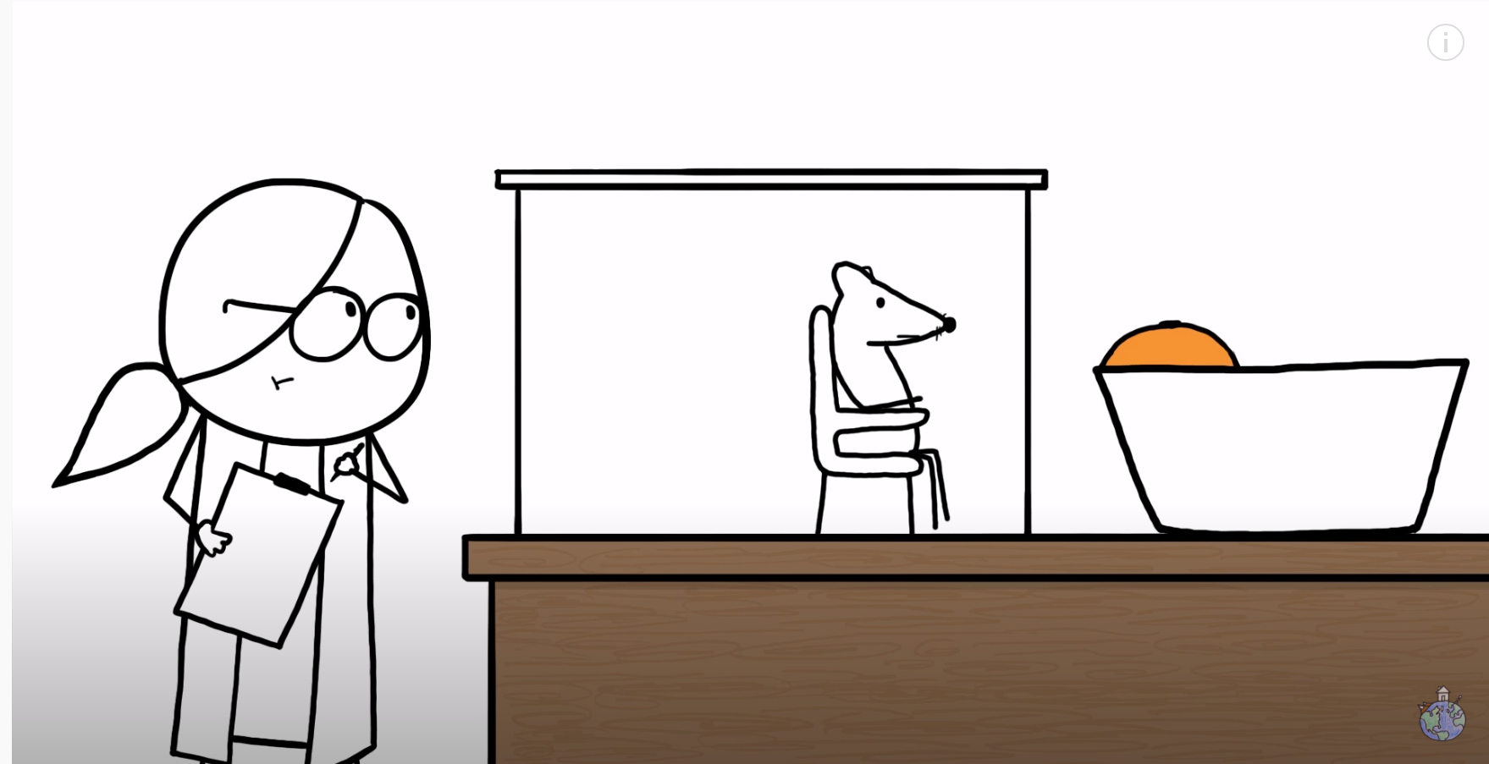

<https://www.youtube.com/watch?v=AvB0q3mg4sQ>



**Culture**

Culture is an integral aspect of development for all human beings throughout our lifespan. Culture refers to “… the set of distinctive spiritual, material, intellectual and emotional feature or society or a social group” (UNESCO, 2001). The term culture describes a shared sense of meaning that shapes a group’s way of life. Culture may be expressed through collective beliefs, stories, behaviours or practices and may be embedded with symbols and rituals that hold shared meaning.

Children growing up in different cultures receive difference inputs from their environments and we begin to integrate sensory data according to our cultural context long before we have the capacity to think about or understand culture as a concept.

Culture is a complex construct within the context of Australian society. There were over 500 different First Nations groups across the continent at the time of colonisation, with many distinct beliefs, languages and ways of life across these groups. Australia today is home to people who have arrived from over 200 countries. Whilst Australia’s dominant cultural narrative is heavily shaped around the beliefs and practices of those from British and other white European backgrounds, this does not necessarily represent the lived experience of many First Nations people and other Australians.

One dimension upon which cultural difference may be viewed is the collectivism – individualism spectrum. Collectivist cultures emphasise interdependence, with focus given to relationships and the needs and goals of the broader group. In individualist cultures individual goals, autonomy and self-reliance are more valued and prioritised. Such differences can shape aspects of child development including identity, emotions and cognition from an early age.

Culture is shared, taught and re-interpreted across generations over time. Whilst it is important to acknowledge that culture is fluid and dynamic, it is also important to recognise the distinctiveness and persistence of culture over time. This is significant in the context of colonisation and assimilation policies such as has occurred in Australia in relation to First Nations people.

**Adolescence**

Adolescence represents a significant transitional stage of physical, neurobiological and psychological development as well as social role transition.

The concept and definition of adolescence differs across cultural contexts and has evolved over time. In many cultures, particularly within industrialised societies, adolescence is seen as a unique and often difficult developmental stage which is becoming increasingly prolonged.



Earlier onset of puberty, changing knowledge about human brain development, delayed timing of social role transitions such as marriage and parenthood and an increasing focus of sustained education have all contributed to shifting perceptions of when adolescence begins and ends.



**CHILD DEVELOPMENT:**

**REFLECTIVE QUESTIONS**

**KEY MESSAGES:**

* Healthy development occurs within the context of caring and supportive relationships
* Every area of development impacts on other areas
* We become who we are as a result of a mix between genetics, temperament, environment and experiences

**Think about a child in your care or a child you have known.**

**Identify what some indicators of normative development within this age range are.**

|  |
| --- |
|  |

**What do you think children in the selected age group need most to achieve these developmental milestones?**

|  |
| --- |
|  |

**Brain Development**

Explosions in research in the field of neuroscience since the 1990s and technological advances such as functional MRI have allowed us to develop a new level of understanding about the functioning and development of the human brain. Prior to this many professionals still believed that the structures of an individual’s brain were genetically pre-determined at the time of birth.

We now have a range of evidence which shows that our brains continue developing well after birth in response to our environment, and that some parts of our brain remain quite amenable to change even later in life. This understanding is an essential building block for being able to respond effectively to the needs of children who have experienced trauma.

By knowing *how* the brain develops and changes and *which* part of the brain is responsible for which functions, we can be better equipped to interpret the impact of developmental trauma on children and to be purposeful in our caregiving and interventions.

***“The brain … is not an inanimate vessel that we fill with information. Rather it is more like a living creature with an appetite, one that can grow and change itself with proper exercise and nourishment”.***

**Doidge, 2007**

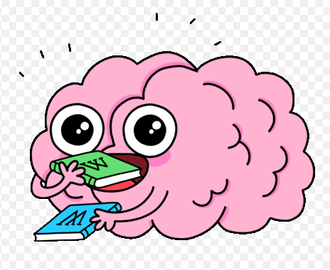

**Key Functions of the Brain**

The human brain is an amazing organ. The brain’s primary function is to ensure that we respond to our circumstances in an adaptive way. In order to do this, the brain must:

* **SENSE -** Detectsensory information from our external environment and our internal world.
* **INTEGRATE -** Process the incoming data and communicate it to the rest of our body.
* **STORE -** Retain information for future use.
* **ACT -** Coordinate a response to the information (behaviourally and physiologically).

These processes help us to survive and function optimally (for the environment we find ourselves in).

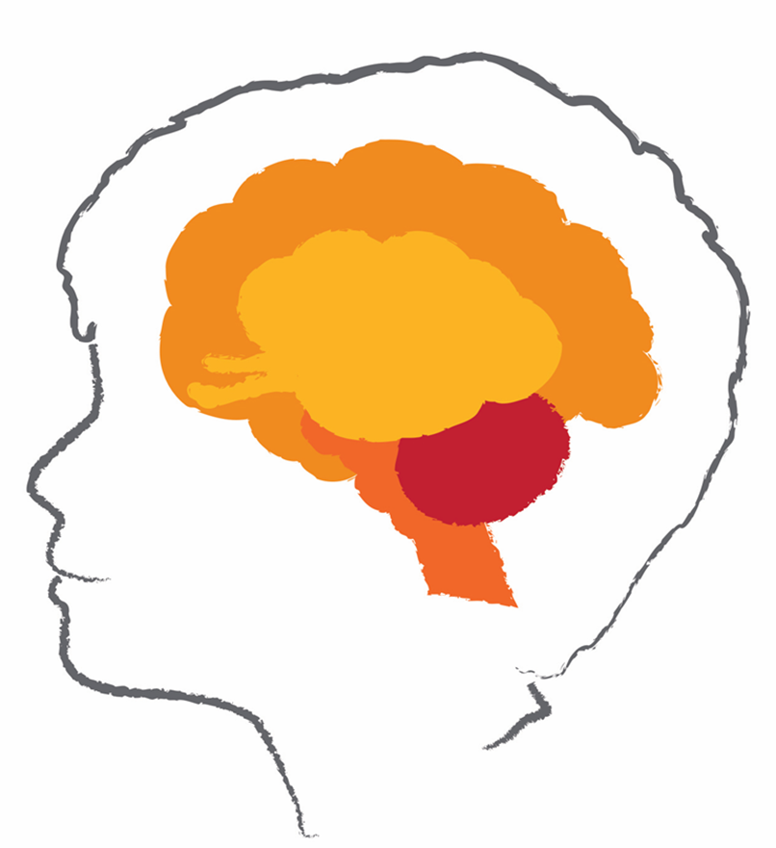

**Vertical Brain Development**

The brain develops sequentially from bottom to top, and from least complex to most complex. Development begins in the early weeks of pregnancy (three weeks after conception) and whilst most active in the first three years of life, continues throughout the lifespan. The main difference between brain development in a child and an adult is a matter of degree. The brain is far more impressionable in early life than in maturity. It simply doesn’t learn; it is always “learning to learn”.

**Neurons and Neuronal Connections**

**Neurons** are single cells, usually what people mean when they say “brain cell”. They are often described as the building blocks of the brain. Neurons begin to form 6 weeks after conception and by birth an infant has approximately 100 billion, most of which have developed by the 24 week mark. At certain points in time, 500,000 neurons are being generated per minute in the developing infant’s brain. Whilst neuronal production continues after birth, this is only to a limited degree.

Like computer circuits, brains process information through the flow of electricity. Neurons interact and communicate with each other through electro-chemical exchange creating **synaptic connections.** This enables the development of **neuronal pathways.** However unlike computer circuits, our brains are not fixed structures. Whilst genes are responsible for the basic wiring plan within human brains – for forming all of the cells (neurons) and the general connections between different brain regions, environment and experience are responsible for fine-tuning those connections. Every experience – seeing a rainbow for the first time, reading a book, rolling a ball – excites some neural circuits and leaves others inactive. The more often a specific neuronal pathway is activated, the stronger it becomes.

This helps each child adapt to the particular geographical, cultural, family, school and social groups to which they belong. Human brains are adaptive in that they develop in response to the experiences and environments available to them, particularly in the first years of life. Therefore, at the birth the human brain has few neuronal pathways. The more often a pathway between neurons is activated, the stronger it becomes. “Cells that fire together, wire together.”

For example, each of us is born with the potential to learn language. Brains are programmed to recognise human speech, to discriminate subtle differences between individual speech sounds, to put words and meaning together and to pick up the grammatical rules for ordering words into sentences. However, the particular language each child masters, the size of their vocabulary and the exact dialect and accent with which they speak are determined by environment in which they are raised. Genetic potential is necessary, but DNA alone cannot teach a child to talk. This comes as a result of the thousands of hours (beginning before birth) that they have spent listening and speaking to others.

This capacity to adapt enables humans to survive and function in a wide variety of circumstances. This adaptiveness requires the brain to develop as many neuronal pathways as possible throughout early childhood, storing information indiscriminately without filtering what is “good” or “bad.”

At birth the human brain is approximately one quarter the size of an adults, growing to 80% of its adult size by the time a child turns three. At this point it contains 1000 trillion neural connections. The brain is 90% of its size by age six.

In early childhood, new neurons and synapses are formed at an amazing rate, up to 40,000 new synapses per second at some points. This rapid expansion means that the brain ends up with far more neurons and synapses than are needed, known as **“synaptic excess.”** However, the human brain is biologically driven towards efficiency, and as synaptic excess undermines this, it then works to correct this through processes of **pruning** and **myelination**.

Synaptic pruning refers to the process by which extra neurons and synaptic connections are eliminated in order to help the brain become more efficient. The process is similar to pruning a rose bush – by cutting away weak branches, others flourish. Pruning is believed to begin as early as two years of age up until early adulthood. By the age of 10 almost 50% of the synapses present at age 2 have been eliminated.

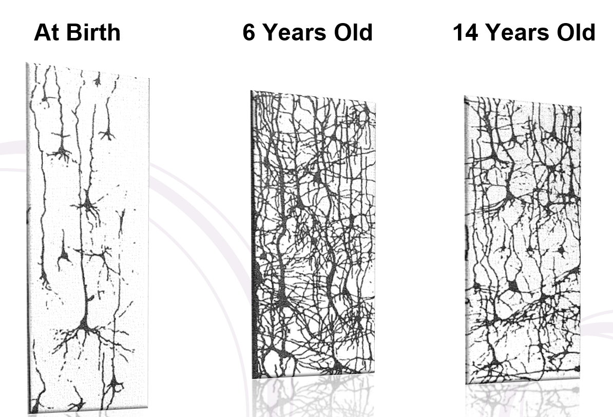

Myelination is where the **axons** (nerve fibres) of neurons are coated in **myelin** (a fatty white substance which acts like a protective coating) – a bit like how the plastic sheath of a power cord protects the electrical wires inside. Myelinated neurons are more efficient at conducting messages. The pathways which are being utilised the most during the developmental periods when myelination is occurring are the ones which will be protected in this way.

Myelination and pruning occur in different areas of the brain at different critical periods. However, research suggests that pruning and myelination at the adolescent period may contribute significantly to an individual’s functioning into adulthood. The circuits which are actively engaged remain, whilst those underutilised diminish. This equates to a principle of “use it or lose it.” For example, an individual who is speaking a second language or playing a musical instrument at this developmental phase is much more likely to retain this ability as they mature.

The brain has the ability to reorganise itself by forming new neuronal connections throughout life. This capacity is known as **neuroplasticity**. Neuroplasticity allows neurons to compensate for injury and disease and to adjust in response to new situations or changes in the environment.

Neuroplasticity involves three components:

* Creating and strengthening synaptic connections (synaptogenesis)
* Stimulating new neurons to grow (neurogenesis)
* Increasing the sheathing along the axonal lengths to enhance conduction speed of neuronal impulse (myelinogenesis)

During childhood, plasticity is at it’s greatest meaning that children’s brains are more open to learning and enriching influences, however they are also more susceptible to negative impacts should their environment prove to be impoverished or un-nurturing. This means that younger children demonstrate the greatest developmental vulnerability to harm. However, in the context of foster care, it is also important to note that neuroplasticity provides us with reason to remain hopeful about the capacity of children and young people to recover from the impacts of developmental trauma. Providing children and young people with trauma-informed care and intervention as early as possible (when levels of neuroplasticity are highest) will maximise the potential for healing to occur.

Watch the following summary of child brain development:

Experiences Build Brain Architecture: Center on

the Developing Child at Harvard University

 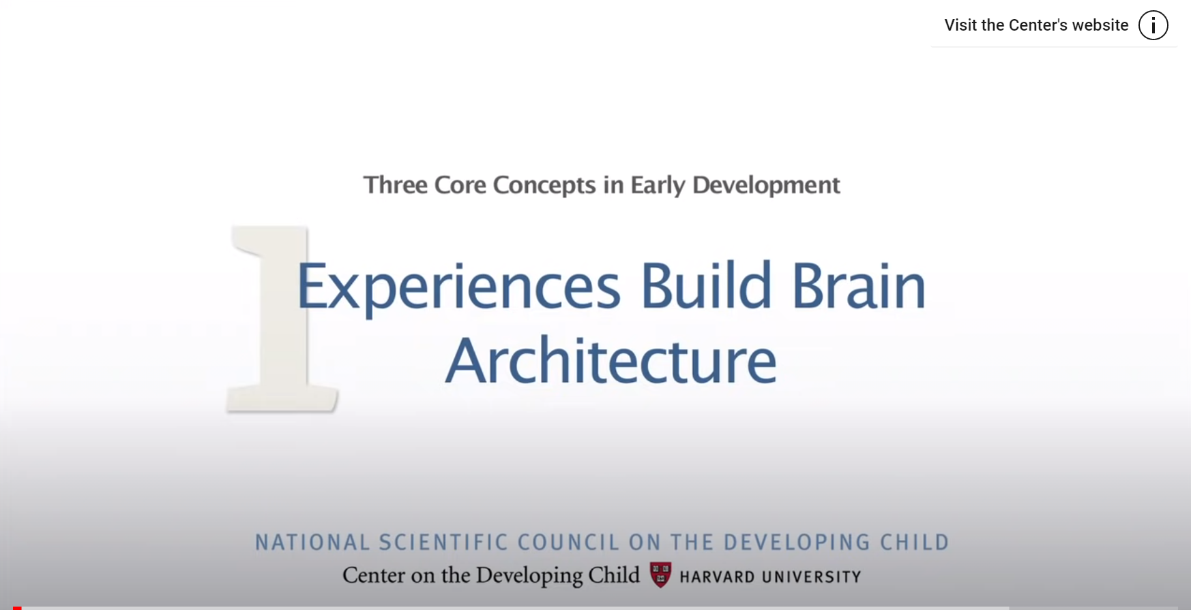

<https://www.youtube.com/watch?v=VNNsN9IJkws>

**Vertical Brain Development**



The brain develops vertically and sequentially over time. The first structures of the brain to develop form the foundation for those to follow. The brain continues to develop with each successive part responsible for more complex functions. The plasticity of the brain increases sequentially from bottom to top, with the upper regions of the brain the most capable of adaptation.

|  |  |  |  |  |  |
| --- | --- | --- | --- | --- | --- |
|  | The Brain Stem develops whilst babies are in utero. It is responsible for key body functions such as controlling heart rate, body temperature and blood pressure. These structures are the least capable of change. | | | | |
| The Cerebellum develops throughout the first two years post-birth. It is responsible for movement and interpreting physical sensory stimulation. | | |  | | |
| The Diencephalon is often reffered to as the “Post Office” of the brain due to its function as a sorting and sending centre. The diencephalon develops mainly after birth.  Two key components of the diencephalon are the Thalamus and the Hypothalamus. The hypothalamus acts as a control centre for certain metabolic processes and activations of the Autonomic Nervous System, including thirst, hunger, and attachment behaviour. The thalamus relays sensory and motor signals to the cerebral cortex and plays a key role in the regulation of sleep, consciousness and alertness.  The thalamus has 2 possible routes – a slow or a fast pathway. When there is no threat detected, information gets sent to the cortex. When there is threat detected, the information gets sent to the amygdala, activating a survival response. | | | | |  |
|  | | The Limbic System evaluates the significance of sensory input in preparation for keeping it in our memory or forgetting it. It stores and helps interpret our emotional state. It also stores certain kinds of memories of experiences without requiring any awareness about the process of remembering (unconscious or implicit memory). The limbic lobe develops mainly after birth. | | | |
| The Hippocampus is involved in the formation of explicit memory, hence its identification as the “Brain’s Historian”. It plays a key role in ensuring that experiences are stored with contextual information about time and space. The hippocampus matures between 2 and 3 years of age. | | | |  | |
|  | | Forming part of the Limbic system, the Amygdala is often referred to as the “Smoke Detector” of the brain due to its central role in detection of threat. The amygdala is active at birth and is highly responsive and sensitive to sensory input, particularly those from other humans. When it senses danger, it quickly recruits other parts of the brain and body to respond. | | | |
|  | |  | | | |
| The Cerebral Cortex is the largest part of the brain and is responsible for higher-level thinking, reasoning and conscious processing. It stores explicit memories about events, people and experiences. It provides the basis for self-reflection or the capacity to think about thinking. | | |  | | |
|  | | Lying at the very front of the brain, the Prefrontal Cortex acts as the CEO of the brain, controlling “executive functions” such as planning, working memory, organization, and modulating mood. The prefrontal cortex undertakes a period of rapid growth in adolescence, however doesn’t completely mature until the mid to late 20’s. | | | |

**Horizontal Brain Development**

The brain not only develops vertically in a sequential way, it also develops horizontally. Research shows that each hemisphere of the brain has distinct properties and different functions.

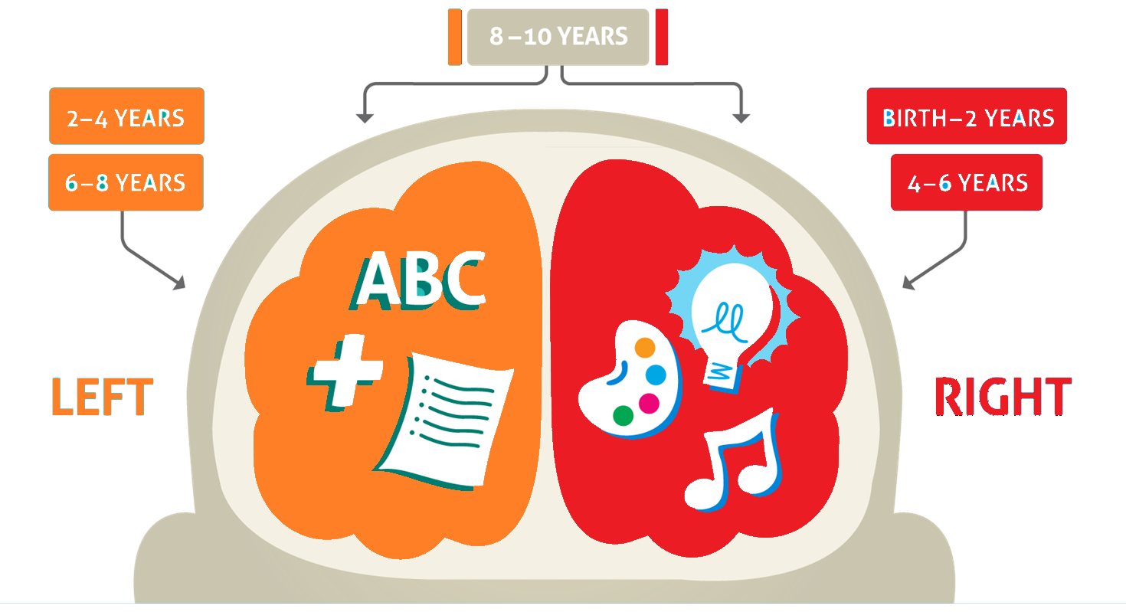

Essentially, the **right hemisphere** of the brain is holistic, convergent and able to see the “big picture”. The right hemisphere stores and processes feelings, creativity and intuition. It is oriented in the present moment.

The **left hemisphere** of the brain is divergent, linear, and focuses on one thing at a time. The left hemisphere deals with more logical experiences and challenges, such as language and mathematics. It looks for patterns and connects past experience to the present and future.

Research suggests that from birth until about two years of age, the right hemisphere of a child’s brain is developing at a greater speed than the left. After age two, development of the left hemisphere then takes over. Intense development continues to oscillate between the hemispheres approximately every two years up until children reach eight years of age.

This pattern of development across the hemispheres is important as it has implications for how children from the one family can be affected in sometimes vastly different ways by the same trauma experiences, depending which hemisphere was more actively developing at the time. Both hemispheres are required for healthy development and functioning.

The two hemispheres are connected by a thick tract or nerves beneath the cortex called the **Corpus Callosum.** The corpus callosum allows the two hemispheres to communicate and to integrate. The corpus callosum undergoes significant development in children between the ages of 3 and 6 years, supporting advances in attentional capacity and behavioural planning. Between the ages of 6 and 13 development in the corpus callosum is significant in relation to language and memory.

**Integration**

In a healthy brain, energy flows in all directions, up/down, sideways, inside/out. Integration is the key to well-being and occurs vertically and laterally within the brain. The brain develops through the creation of neural pathways which connect different regions of the brain together. Neuronal connections are strengthened best when an individual repeats an experience over and over. If the experience is not repeated, the connection will disappear. To master a motor activity for example, a child is required to repeat and repeat the motion and in the practice of it, becomes more precise and faster. Similarly, when playing a musical instrument, learning timetables, singing a song, reading or dancing. These neural pathways in the brain enable each individual to efficiently interpret the world, their reactions to it and prompt relevant responses. The brain establishes these pathways as templates to be able to quickly compare a new situation with memories previously stored and ultimately interpret the next steps or actions that will be taken.

Integration of neuronal networks shapes the thoughts, feelings and actions of children and young people. The greater the number of pathways, the more the functions of the brain become integrated.

Integration enables individuals to perform functions such as apply words to feelings, thread together the experiences that build memory of routines and to combine repeated interpersonal interactions over time in a way that equates to the development of trust with another person. Humour is an example of how horizontal integration – connection between the left and right hemisphere – supports functioning. The left hemisphere understands the words that are said in a joke and looks for cause and effect. The right hemisphere processes the emotional impact of those words and assesses the non-verbal communication of the speaker to give a complete understanding of the experience. Some people may not “get” a joke because they only hear the words while others may not understand the meaning of the words but respond purely to the joke teller’s non-verbal communication telling them, “this is funny!”

**Memory**

There are two main types of long-term human memory, which operate through different mental processes.

**Declarative or Explicit Memory**

These types of memories are conscious memories of facts and events. Explicit memory develops after birth as brain systems form. They are consciously encoded and retrieved.

There are two components of explicit memory:

**Semantic memory:** Develops from approximately 18 months of age. Semantic memory supports our knowledge of the world, for example being able to name the capital city of a country.

**Episodic memory:** Develops from approximately age of two to three years. Episodic memory supports our ability to recall specific personal events that occur at different points in time. For example, remembering what you ate for breakfast or your first day at school.

Although it appears that many brain systems are involved in the storage and retrieval of explicit memory, of particular importance is the hippocampus. When we have an experience for the first time, the hippocampus forms a neuronal connection which allows us to recall this in the future. Repeated exposure to the same experience will strengthen this connection and allow for faster retrieval.

**Non-Declarative or Implicit Memory**

These type of memories begin forming in utero before birth. They are stored and retrieved subconsciously and are non-verbal. Implicit memories can affect thoughts and behaviours without our awareness.

Implicit memories include basic sensory, emotional and bodily associations and support us to form templates about the world around us. These templates create generalisations of early experiences.

There are several forms of implicit memory. One of the most prominent forms of implicit memory is procedural memory. Procedural memory allows for the performance of certain tasks without conscious awareness, for example tying one’s shoelace or driving a vehicle.

The amygdala plays a key role in the storage and retrieval of implicit memories, particularly those consisting of intense emotions or sensations.

**Adolescent Brain Development**

|  |  |
| --- | --- |
|  | Significant neuronal development takes place during the adolescent years and the structure and function of the brain is very different at this time than throughout childhood or adulthood. Developments in the limbic system impact pleasure-seeking and reward processing, emotional responses and sleep regulation. Activity in this region may contribute to overly emotional reactions to events, whilst the increased importance of peer relationships is one element contributing to a heightened desire for risk-taking behaviours. |

In an adult brain, the fully-developed pre-frontal cortex (PFC) curbs impulses coming from other parts of the brain. The PFC has the “final sign-off” on how we react in situations. Adolescents do not have full access and use of this region as it remains under construction at this time. This impacts multiple domains including attention span, working memory, decision-making, planning, problem-solving, social cognition, attuned communication, motivation, organisation, self-regulation, impulse control, response flexibility, self-awareness and judgement and reasoning. Changes to the PFC occur later in adolescence than the limbic system changes. Compared to adults, adolescents will utilise different brain structures to make decisions. Adult brains which are more integrated will recruit different regions to work together when responding to situations whereas adolescents will use local regions.

The below clip is a summary of adolescent brain development:

**The Adolescent Brain: Dan Siegel**

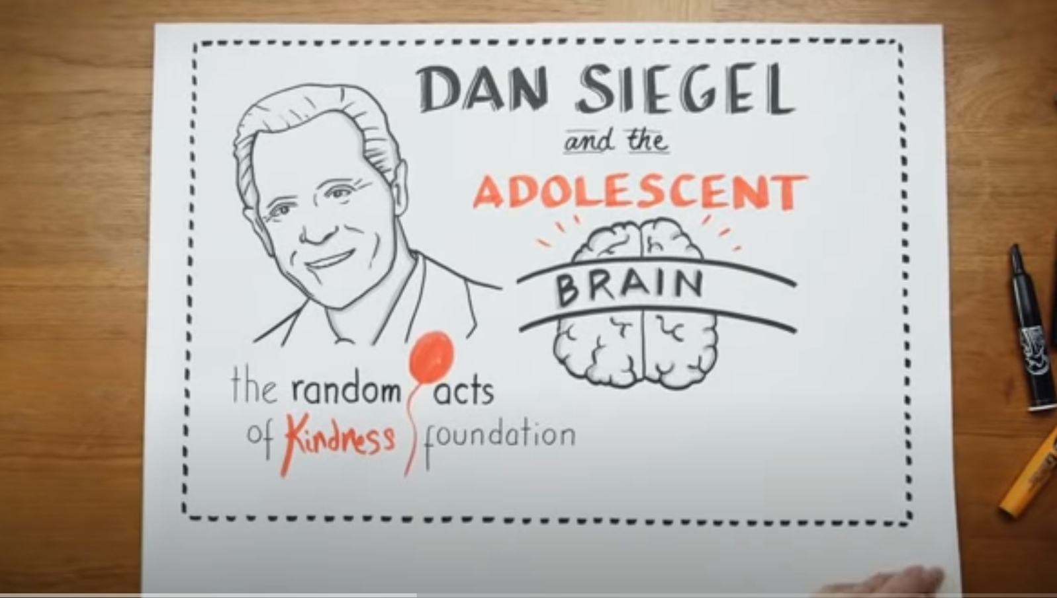 

[**https://www.youtube.com/watch?v=0O1u5OEc5eY**](https://www.youtube.com/watch?v=0O1u5OEc5eY)

**BRAIN DEVELOPMENT: KEY MESSAGES**

* Brain development is most rapid in the first years of life
* The brain develops in a sequential fashion
* The brain is integrated both vertically and horizontally
* Integration is the key to optimal brain development and function
* The brain develops in response to its environment and experiences
* The brain develops through repetition
* The brain is always capable of change



**BRAIN DEVELOPMENT:**

**REFLECTIVE QUESTIONS**

**What stands out for you as important about brain development when caring for a child who has experienced developmental trauma?**

|  |
| --- |
|  |

**References**

Doidge, N. (2007) *The brain that changes itself.* New York: Penguin Group

Department for Health and Human Services (2015) Aboriginal Therapeutic Home-Based Care Program and Funding Guidelines

The Circle Program: An Evaluation of a Therapeutic Approach to Foster Care (2012)

Siegel, D. (2015) *Brainstorm: The power and purpose of the teenage brain.* New York: Tarcher/Penguin

Siegel, D. & Payne, T. (2012) *The whole-brain child.* Brunswick: Scribe

Winkworth, G., & McArthur, M. (2007). Developing communities of support for vulnerable children: Shifting the focus from risk. Communities, Children and Families Australia, 3(2).