**TRAINING WORKBOOK**

**Module #2:**

**RELATIONSHIPS**

Whenever you see this icon throughout your workbook, it is time to stop and reflect on what you have learnt so far as it relates to children you have cared for. Make some notes in the space provided.

Whenever you see this icon throughout your workbook, you will find a link to a video. Click on the link and press the CTRL button on your keyboard to play the clip.

Whenever you see this icon throughout your workbook, you are being asked to stop and take a look at one of the provided Handouts, which will provide more information about the topic.

This training requires you to think about how the material applies to specific children you have cared for. If you feel that you do not have enough experience caring for children in out of home care to respond to any of the reflective questions, a Case Study is included in the Handouts. Refer to this if needed.

**HOW TO USE THIS WORKBOOK**

This workbook is part of a blended training program which combines self-paced learning with direct training. After completing this workbook, you will be participate in interactive discussion sessions facilitated by a staff member from Australian Childhood Foundation’s Therapeutic Services team.

The information in this workbook is divided into modules. Accompanying the written material, we have also provided some links to short video clips which you can access on YouTube. You have also received some Handouts which accompany the written material in your workbook.





Throughout each module you will also find summaries of key messages and a small list of questions which help you to reflect on what you have learnt and how it relates to your experience caring for children.



Time will then be scheduled for you take part in a group discussion facilitated by a member of the ACF Therapeutic Services Victoria team. This will give you an opportunity to explore the concepts and ideas covered in the workbook.



**MODULE TWO: RELATIONSHIPS**

**The Importance of Relationships**



***“There is no such thing as a baby, there is a baby and someone.”***

**(Donald Winnicott, 1947)**

Attachment theory is an important field of research for us to explore in regard to understanding the needs of children who have experienced developmental trauma.

In referring to attachment and attachment relationships, we are describing the emotional bond that initially develops between a baby and their primary caregiver and forms a lasting connection. Beginning in infancy and continuing through early childhood and beyond, attachment behaviours will change over time however are significant to human wellbeing throughout the entire lifespan.

All human beings are born with an innate instinct to seek proximity to a specific person or persons who will comfort, protect and help to organise their feelings. Unlike some animals species, human beings are incapable of survival at birth in the absence of relationship. The most powerful aspects of a child’s world influencing their development are the relational experiences and environments available to children throughout their early years. Child can only develop when they are connected with other humans, brain to brain and body to body. Infants rely on their primary caregiver for the provision of safety, nurturing, sustenance and love. However we don’t just need any relationship, we need the right type of relationship. Children’s brains develop best when they have access to adults who are attuned, calm and responsive, and whom engage with them in ways which are both stimulating and soothing, safe and consistent.

**Safety and Security**

A **secure base** is created when caregivers are reliably available and respond sensitively to the child’s needs. When the caregiver provides consistent, attuned caregiving the child feels safe and secure. Their curiousity kicks in and they have the confidence to explore their world, to develop new skills, to learn and to grow. They can do this safe in the knowledge that their caregiver will watch over them, share in the delight of new discoveries or mastery of a new skill, and provide help (just enough) when needed.

When a child has explored enough, or they become tired, frustrated or scared, they need to know that they will be welcomed back lovingly and that their need (for protection, comfort, assistance) will be responded to in a timely and helpful way.

A strong connection between children and their caregiver is critical to children being able to understand and feel safe in their world. Secure attachment with an attuned, sensitively responsive and empathic caregiver allows children to feel safe and loved unconditionally, learn about emotions (their own & others), develop capacity for regulation, form positive beliefs about self, relationships and the world and effectively manage shame.

Watch this clip which takes you on a short tour of the “Circle of Security”

**A Tour of the Circle of Security**

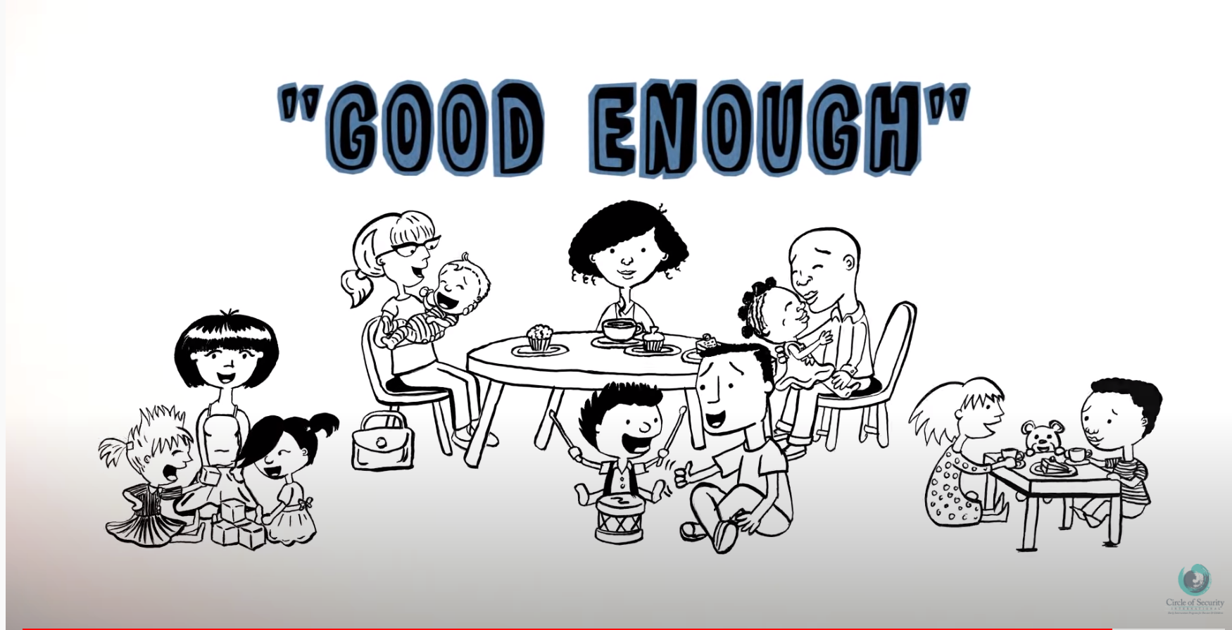

<https://www.youtube.com/watch?v=1wpz8m0BFM8>



**Attachment Through A Cultural Lens**

When considering the importance of relationships in children’s lives it is important to acknowledge that attachment theory has largely evolved from a Western, individualistic social context. Whilst many researchers have proposed that the concepts of attachment are universal, applying attachment theory across non-Western cultures requires caution. This is particularly important when considering attachment in the context of more collectivist cultures, including Aboriginal and Torres Strait Islander communities, where some of the framework’s core concepts may be inconsistent with child rearing practices.

In some cultural contexts, values of relatedness and concepts of family may extend beyond the “nuclear” family within a household, and a collective responsibility for the care and nurture of children may be held by extended family or community members. The concept of mother may apply to a group rather than one person, seeing infants seek comfort and feeding from several caregivers. Whilst cross-cultural attachment research has established that sensitive care and exploratory and proximity-seeking behaviours by infants are consistently important, the specific ways these manifest and what can be interpreted may differ across various cultural contexts.

Within some cultural contexts the parent-infant dyad may be less central to a child’s sense of security. Therefore, it may be much more helpful to think of an attachment network around a child, where over-lapping relational bonds support children to be healthy and safe.

It is also important to consider the cultural meaning of social competence and what traits are viewed as socially acceptable or desirable when considering caregiving behaviours and how this may shape relational templates. Seeking to understand the underlying goals and beliefs behind parenting behaviours as they relate to development of future competence in children may help us see that what may be considered unhelpful parenting behaviour in one context could be viewed as adaptive and appropriate in another. A simple example of this is to consider the degree to which sociability and certain types of open communication such as eye contact may be encouraged in some cultural settings, but discouraged in others where they indicate a lack of respect.

**Regulation**

Regulation is being able to monitor and manage our reactions to our environment and experiences. Our early relationship experiences help us organise and regulate our emotions and behaviours.

**Sympathetic Hyperarousal**

**Window of**

**Tolerance**



**Parasympathetic Hypoarousal**

Through the caregiver-child relationship, the child can be supported to develop a wide **“Window of Tolerance”** which is a term describing the zone within which various intensities of emotional and physiological arousal can be processed without disrupting the functioning of the system.

Watch the following video to understand the Window of Tolerance through the metaphor of the River of Life.



**Tracey Farrell: Window of Tolerance Reimagined**

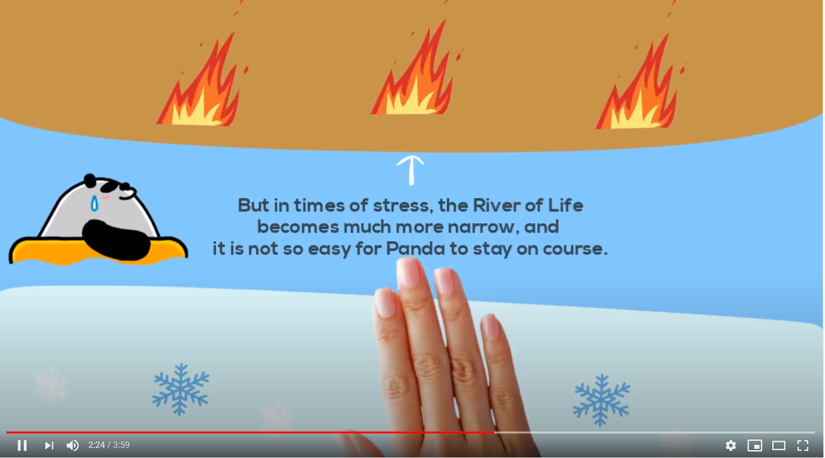

<https://www.youtube.com/watch?v=ZVEDueyZ2C4&t=71s>

Despite being born with the capacity for feeling deep emotions, babies are unable to keep themselves in a state of equilibrium, lacking the skills to regulate either the intensity or the duration of those emotions. The primary caregiver is the infant’s prosthetic cortex – taking in information, processing it and giving it back to child with meaning, and if required offering soothing or a solution. Through this repeated process the child learns to identify, manage and integrate their own emotions (e.g. anger, excitement, distress, joy). They also learn to regulate their physiology (breathing, heart rate etc).

When caregivers can regulate their own emotions and reactions, they pass this capacity onto their infant children. When the parent can keep themselves well regulated, that is recovering from negative emotions like anger, sadness, fear and anxiety, they teach this to the child, just by doing it themselves. Connected infants will look to their parent to decide how to feel about something new. For example, when a stranger enters the room the baby will look at the caregiver’s face, if there is a smile the baby will feel safe, if there is surprise the baby might be a little restless, if there is fear the baby will be afraid. If there is anxiety initially, but this moves to calm, the baby will calm, if not they will stay dysregulated until the parent is calm again.

**Attunement**

Attunement is one of the key factors in supporting healthy attachment relationships. It refers to the ability of the caregiver to know, read and match the child’s feelings and needs.

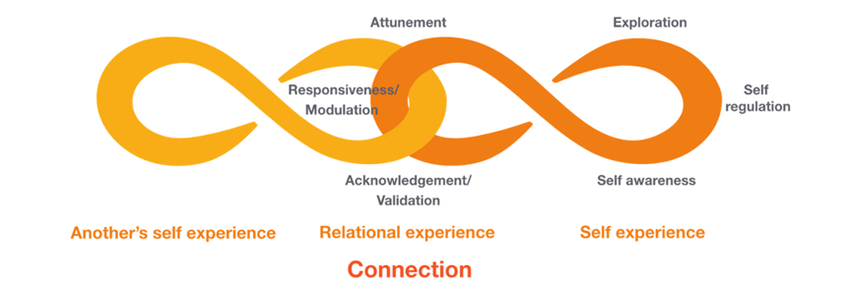

Because of the infant’s innate need to connect with a caregiver in order to survive, they will demonstrate a range of behaviours which are designed to elicit a response from those around them, for example, crying, vocalisations, bodily movements, facial expression and eye contact. These behaviours are all designed to cue caregivers to the infant’s needs.

Attachment relies on the ability of the primary caregiver to read and respond to the infant’s cues reasonably consistently and predictably over time. When this occurs neurochemicals are released that assist in building and reinforcing key neurological pathways

Attunement is achieved by the repetitive cycle of positive experiences that a child has with their primary caregiver. The experience of being seen and understood develops a mental model or inner expectation for the child that their needs are important and their goals can be achieved.

Through attunement, the child is able to learn about their own and others’ emotions. This support the child to be in sync with other and accurately read the intentions of others. These capacities are key building blocks to the development of empathy.

Watch the following video clip for an example of attunement in the natural world.

**David Arredondo: Attunement and Why It Matters**



<https://www.youtube.com/watch?v=ZbRrxw-H6xA>



**Rupture and Repair**

One significant cause of mis-attunement in relationship between caregivers and infants is the child’s experience of limit-setting. As children develop, caregivers need to begin placing limits on their behaviour. This is an important aspect of socialistion, whereby children begin to develop an understanding of the world they live in and the skills to regulate their own emotions and behaviour.

Limit-setting becomes most prevalent as the mid-brain (diencephalon and cerebellum) develops and the child starts to become more mobile and adventurous. As the child starts to explore and experience more autonomy, there is a sudden need for caregiver to place limits on the child’s behaviour. For example, think of a young child reaching towards a cup of hot tea or crawling towards a power outlet, requiring a caregiver to intervene to ensure the child remains safe.

The child initially experiences the caregiver’s intervention as a break in the relationship. In a healthy family, the child has come to expect attuned responses from their caregiver and they therefore interpret the limit-setting as conveying the message “YOU are BAD.” This initially shocks the infant who experiences shame.

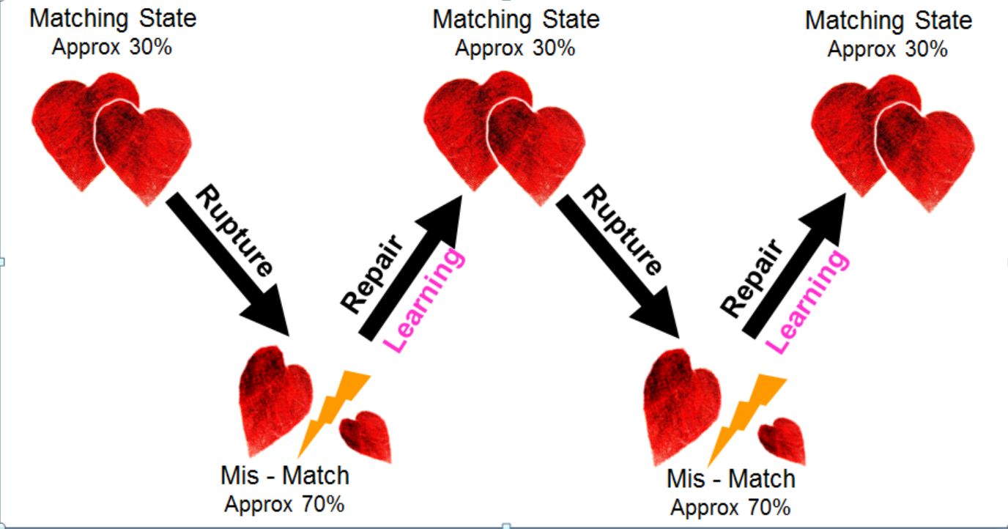

Occasions of mis-attunement within caregiver-child relationships may also occur for many other reasons, such as a caregiver being distracted and needing to tend to other things at time when the infant is seeking connection and responsiveness (other children, household tasks, phone calls, toilet break etc).

A good caregiver is not one who is attuned to their infant’s needs 100% of the time. The ‘good enough’ caregiver is one who once misattuned can regulate the infant’s negative state by accurately re-attuning in a timely manner. This teaches the child that all emotions are tolerable and can be contained and managed and begins building skills for self-soothing.

The process of re-attuning or repair reassures the child of the security of the relationship and enables continued development. The child is able to integrate pleasure and frustration, affection and anger within self, and in relationship to their parent.

***The difference between shame and guilt is the difference between “I am bad” and “I did something bad.”***

***Brené Brown***

  

Watch the following clip which explores infants experiences of mis-attunement and repair in the caregiving relationship.

|  |  |
| --- | --- |
| C:\Users\lpyle\AppData\Local\Microsoft\Windows\INetCache\Content.MSO\9463A5D7.tmp | Still Face Experiment: Dr Edward Tronick    <https://www.youtube.com/watch?v=apzXGEbZht0> |

**Shame**

When repair or re-attunement doesn’t occur following a rupture in the caregiver-child relationship, the consequence is unresolved shame. Lack of repair leaves the child with painful negative feelings about themselves and their relationship. Shame (“I am wrong/bad/not ok”) differs to feelings of guilt which are attached to a specific action or event (“what I have done is not ok/bad/wrong”) and are generally less painful. Guilt, whilst unpleasant, can lead to feelings of regret and concern regarding one’s impact on others. This can in turn generate helpful responses such as a desire to apologise or repair for the damage that has occurred.

Shame on the other hand, particularly repeated unresolved experiences of shame, leads to a global negative sense of self. Children who experience unresolved shame are likely to feel small and worthless and may be overly concerned by others’ evaluations of them. Experiences of shame are often generalised to devalue the individual’s complete sense of self and can significantly impair functioning.

The process of repair following a relational rupture (re-attunement and reassurance) supports the child to develop a capacity to integrate shame which will be essential throughout their lifetime. Reintegration sets a pattern for resilience, where children learn that mistakes and correction can be tolerated and learned from. Where a rupture has occurred due to a child’s actions (e.g. misbehaviour) the repair process is particularly important as it helps to shift focus from their overall sense of self to their specific behaviour, and from a state of shame to one of guilt/remorse. Integration of shame via relational repair following limit-setting reinforces the caregiver’s care and concern for the safety and wellbeing of the child, thus reinforcing the significance and quality of the relationship. For example, explaining to a child the reason for not allowing them to play with a sharp knife. This supports the child to develop a sense of the caregiver’s good intentions, and over time assists them to become more accepting of limits.

**Internal Working Models (Templates)**

Within their earliest relationships the infant learns about themselves, others and the world around them. An infant achieves a sense of who they are through their primary caregiver. These early experiences become our **internal working models** – templates through which we store and refer back to in order to understand future experiences. In a secure attachment relationship the infant and the parent discover each other, and discover themselves in relation to the other.

The parent or carer’s experience of the baby becomes the baby’s experience of itself. The child discovers him/herself in the mind of the parent

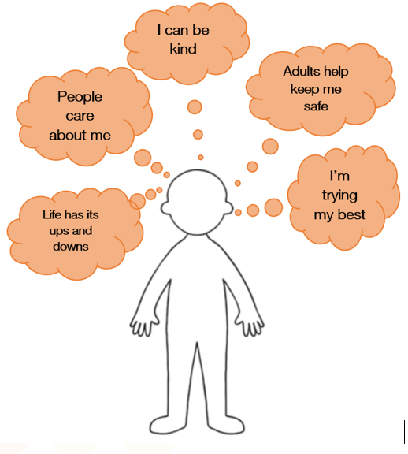

If there is love, the child discovers himself as lovable, if there is fear, the child discovers herself as fearsome, if there is disgust the child discovers himself as disgusting.

Our internal working models are like a set of rules stored in our brain that determine how we view ourselves, others, relationships and the world more broadly. They will strongly influence our behaviour and expectations, particularly in the context of relationships. Children who have experienced attuned, responsive and sensitive relationships will demonstrate the capacity to seek comfort, to trust and to experience empathy.

**THE IMPORTANCE OF RELATIONSHIPS: KEY MESSAGES**

Positive attachment experiences assist children to:

* Feel safe
* Learn about emotions (their own & others)
* Develop capacity for regulation
* Form positive beliefs about self, relationships and the world
* Effectively manage shame
* Accept limit-setting and influence from caregivers



**THE IMPORTANCE OF RELATIONSHIPS:**

**REFLECTIVE QUESTIONS**

**Thinking of a child in your care, how would you describe their internal working model or templates (what are the things they believe about themselves, relationships and the world)?**

|  |
| --- |
|  |

**What behaviours do you find the most difficult to respond to whilst remaining attuned to the child and able to repair the relationship?**

|  |
| --- |
|  |

**Resilience**



***“All children, however great the adversity they have survived, can be helped to adapt and increase their resilience.”***

**(Cairns & Fursland 2007)**

There have been lots of studies undertaken to try to identify the factors associated with resilience. Several common factors have been identified, some of which are personal attributes and others which are situational:

**Personal Attributes:**

* + Pro-social skills / attractiveness to other people
  + Optimism towards the future
  + Self esteem
  + Sense of autonomy and control
  + Sense of humour
  + Flexibility
  + Sense of adventure
  + Capacity to endure and find outlet for emotions

**Situational Factors:**

* + Positive attachment relationships
  + Supportive social network
  + Hope and positive expectations
  + Decreasing stockpile of problems
  + At least one positive life experience
  + One good thing leading to another good thing

These factors are clearly interactional and always appear in combination with each other.

Even though we might expect to have more influence over the situational factors, it should also be pointed out that the personal factors are also amenable to change. In fact these are personal attributes than can be developed over time.

All of these attributes can be developed through learning and conditioned to a certain extent by ongoing experience.

Underpinning all these situational factors is the quality of the child’s relationships. This will also interplay with all of the identified personal attributes in important ways.

Positive relationships can help improve poor self-esteem. People who take an interest, who listen, who care and love us make us feel better, improve our image and build our self-esteem.

Carers can help children build resilience by helping them to:

* Build self-esteem and a sense of control over their lives
* Have at least one secure relationship
* Be happy and involved at school
* Explore/pursue their talents and interests
* Focus on their strengths not just problems
* Build hopes and goals for their future and plans for reaching them

Watch the animated clip below which explores some of the factors impacting on resilience to life events and experiences.

|  |  |
| --- | --- |
| C:\Users\lpyle\AppData\Local\Microsoft\Windows\INetCache\Content.MSO\9463A5D7.tmp | Rethinking Resilience: Tracey Farrell      <https://www.youtube.com/watch?v=mlUuY9tUFok> |

**RESILIENCE: KEY MESSAGES**

* The fundamental building block for resilience is a secure relationship.
* Every effort must be made to nurture the development of secure relationships and a support network for the child.



**RESILIENCE:**

**REFLECTIVE QUESTIONS**

**What are the things you do or could do to build the resilience of children in your care?**

|  |
| --- |
|  |

**There are many parts of their life that children living in out of home care have no control over in their life, how can you build in choice and a sense of control for children you are looking after?**

|  |
| --- |
|  |

**The Biology of Safety**

Safety is embedded in our physiology and is a relational experience.

**Neuroception and the Stress Response**

One of the brain’s primary functions is to keep us alive, and as such it is constantly scanning for threat and danger. We therefore have a well-developed internal system for detecting and signalling danger and threat.

**Stress** is a broad term which describes the mental or emotional tension which arises when we face adverse or demanding circumstances. Short-term stress can have positive impacts. Without stress, our brain would be unaware that there is something important happening for it to attend to. Stress can be motivating in prompting us to prepare for an upcoming challenge, for example an exam or work deadline. Acute stress which is short-lived and not repetitive primes the brain for improved performance. Just the right amount of stress pushes us to optimal alertness, behavioural and cognitive performance. Some research shows that moderate amounts of tolerable can actually improve our immune system. Stress also has acts as a warning system to support us in avoiding or escaping threatening situations.

Our nervous system has evolved to respond in a hierarchical manner to its environment depending on what is known as the **Neuroception** of safety**.**



Neuroception describes how neural circuits distinguish whether situations or people are safe, dangerous or life-threatening. This detection occurs outside of conscious awareness. Neuroception explains why a baby coos at a caregiver but cries at a stranger, or why a toddler enjoys a parent’s embrace but views a hug from a stranger as an assault.

Neuroception allows us to engage with others in a way that supports cooperation. To achieve this, we had to be able to turn off our more primitive responses to perceived threat. This ability is essential for our survival and wellbeing as mammals who function optimally in social groups. Our ability to perform functions such as making eye contact, vocalise with rhythm and intonation, display appropriate facial expression and distinguish the human voice from background sounds are all essential to our successful participation in social groups and rely on our evolved nervous system. When we experience neuroception of safety we are able to utilise these functions and activate systems which enable us to participate in everyday life. These systems include exploration, attachment, play, energy regulation, sociability, caregiving and sexuality.

When we do not experience neuroception of safety (rather we experience neuroception of danger), we are unable to activate these systems effectively and instead rely on our defence systems.



Even in the face of perceived threat, our nervous system’s first preference will be to use the **Social Engagement** **System** to modulate calm bodily states and connect with others to increase our sense of safety.

Where this is not available or effective, we retreat down the hierarchy to what is known as **Mobilisation.** This system relies on our **Sympathetic Nervous System** becoming activated and we respond at a physiological level. Our heart races, we experience sweaty palms, blood rushes to our extremities and our digestion slows down.

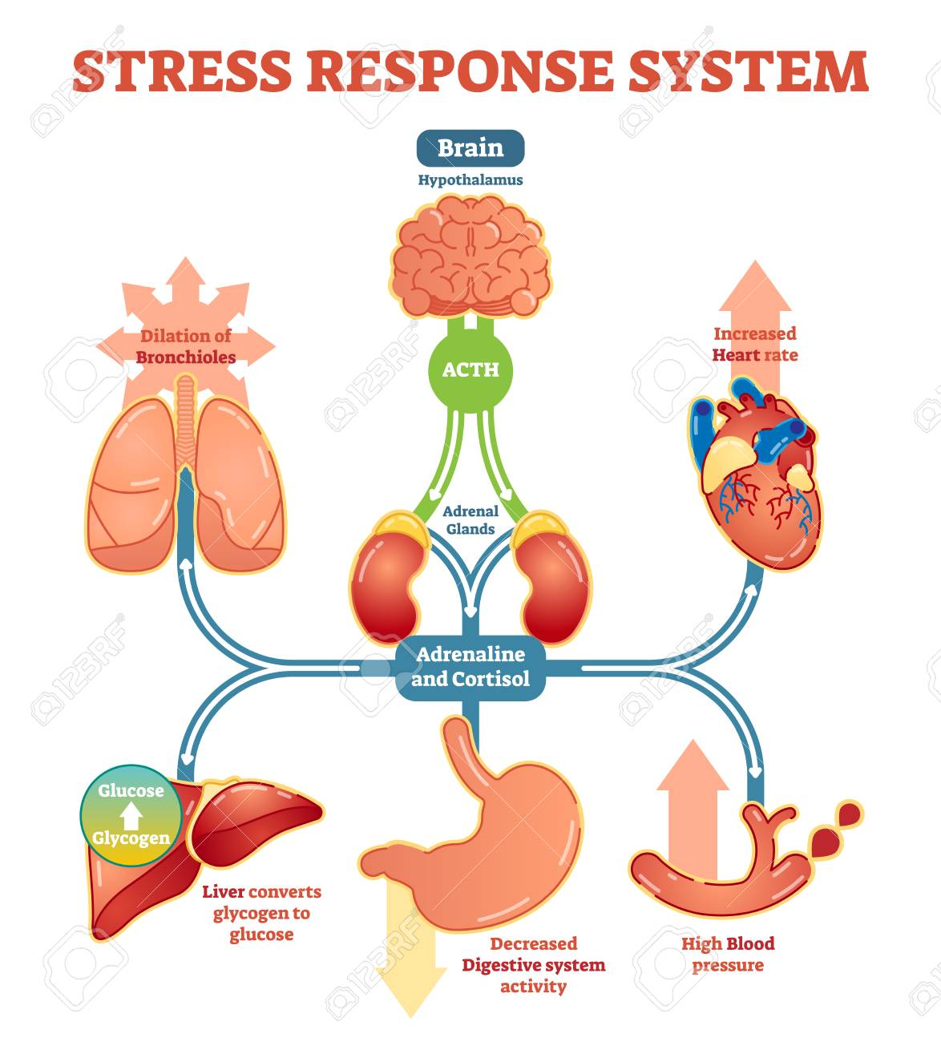

We also respond behaviourally. The physiological changes in our body will trigger adaptive and defensive responses which are oriented towards finding safety in the most efficient and effective way possible. These responses may involve aggression (fight), attempting to run from the threat (flight) or a short-lived stillness (“freeze” or “active freeze”) during which the individual seeks to better understand the situation and prepares for action. Our capacity for rational thinking and reflection will be compromised in this state and our actions will occur instinctively rather than purposefully.



“**Fight” “Flight” “Active Freeze”**

In some situations, the experience of threat is so overwhelming that the nervous system resorts to its most primitive defence system. This response relies on the **Parasympathetic Nervous System** , which produces an **Immobilised** response. In this state we may collapse or submit (sometimes known as a “flop” or “faint” response).

Under some threatening circumstances we may also activate our attachment behaviours in order to maximise our survival. In this case attachment-type behaviours occur in the absence of internal safety and reciprocity. This is sometimes referred to as “fawn” or “friend” response to trauma.

 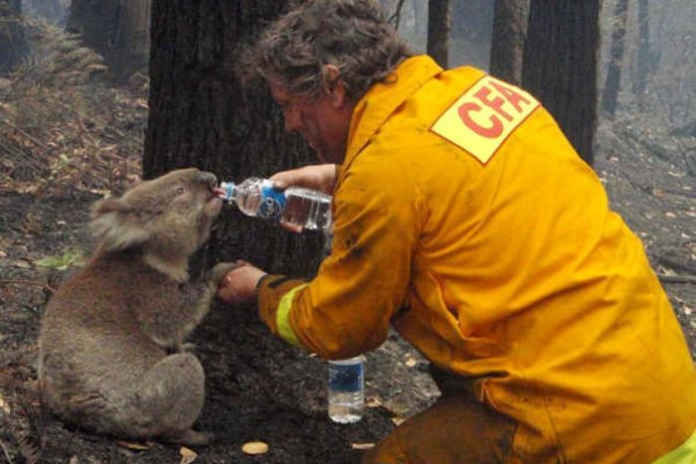

**“Flop” or “Faint” “Fawn” or “Friend”**

* Please note, whilst there is generally clear agreement about the definitions of fight and flight responses, there are some varied perspectives on the terminology and characterisations of other systems. For example, some writers use the term Freeze to describe an immobilised response.

Under real threat, these reactions are useful, protective, automatic mechanisms that help us survive and stop us suffering the full extent of the neurobiological shock we have experienced. These intense processes are effective and helpful over a time-limited period.

**The Fight, Flight, Freeze Response**

 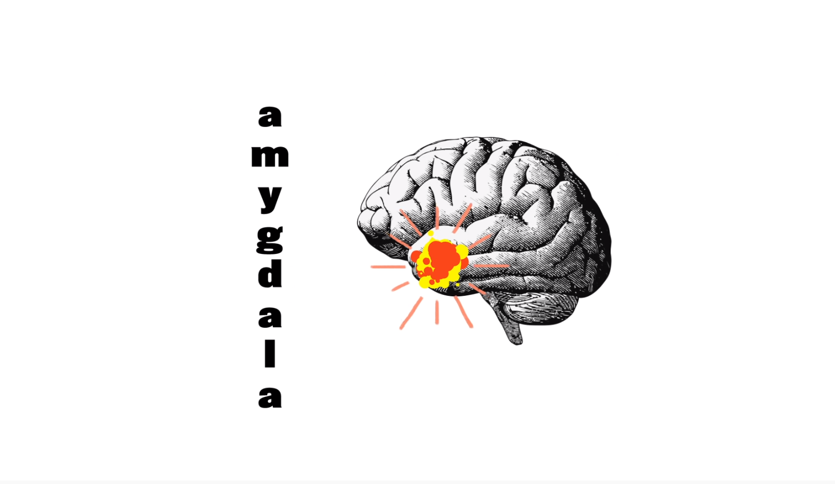

[**https://www.youtube.com/watch?v=rpolpKTWrp4**](https://www.youtube.com/watch?v=rpolpKTWrp4)

**THE BIOLOGY OF SAFETY: KEY MESSAGES**

* Human beings are wired for connection and for seeking safety through relationships
* Our brains and bodies are also wired to effectively detect and respond to threat
* Stress in moderate amounts can have positive effects for humans
* Over time we have developed a hierarchy of nervous system responses to perceived threat
* Our responses to perceived threat are often instinctive and are designed to be adaptive in the context they occur



**THE BIOLOGY OF SAFETY:**

**REFLECTIVE QUESTIONS**

**Thinking of a child you have cared for, what type of response do they demonstrate when they feel threatened? What do you notice in their behaviour?**

|  |
| --- |
|  |

**What do you notice in yourself when you are in situations of high or prolonged stress?**

|  |
| --- |
|  |

**References**

Porges, S. (2011) *The polyvagal theory: Neurophysiological foundation of emotions, attachment, communication, self-regulation.* New York: Norton

Powell, B., Cooper, G, Hoffman, K. & Marvin, B. (2014) *The Circle of Security intervention: Enhancing attachment in early parent-child relationships.* New York, The Guildford Press