TRAINING WORKBOOK

MODULE #3:

TRAUMA
Whenever you see this icon throughout your workbook, it is time to stop and reflect on what you have learnt so far as it relates to children you have cared for. Make some notes in the space provided.
Whenever you see this icon throughout your workbook, you will find a link to a video. Click on the link and press the CTRL button on your keyboard to play the clip.

Whenever you see this icon throughout your workbook, you are being asked to stop and take a look at one of the provided Handouts, which will provide more information about the topic.
This training requires you to think about how the material applies to specific children you have cared for. If you feel that you do not have enough experience caring for children in out of home care to respond to any of the reflective questions, a Case Study is included in the Handouts. Refer to this if needed.
HOW TO USE THIS WORKBOOK

This workbook is part of a blended training program which combines self-paced learning with direct training. After completing this workbook, you will be participate in interactive discussion sessions facilitated by a staff member from Australian Childhood Foundation’s Therapeutic Services team.

The information in this workbook is divided into modules. Accompanying the written material, we have also provided some links to short video clips which you can access on YouTube. You have also received some Handouts which accompany the written material in your workbook.

Throughout each module you will also find summaries of key messages and a small list of questions which help you to reflect on what you have learnt and how it relates to your experience caring for children.

Time will then be scheduled for you take part in a group discussion facilitated by a member of the ACF Therapeutic Services Victoria team. This will give you an opportunity to explore the concepts and ideas covered in the workbook.

MODULE 3: TRAUMA

Defining Trauma
Trauma is the emotional, psychological and physiological residue left over from heightened stress that accompanies experiences of threat, violence and life-challenging events.

Trauma is a response to a perceived threat which overwhelms our capacity to cope and feels outside of our control. Trauma evokes a set of physiological and psychological responses based on fear and avoidance.

Research has identified different types of trauma.

Simple Trauma
Simple trauma is overwhelming and painful. It involves experiences that are life threatening and/or have the potential to cause serious injury.

Simple trauma often has the following characteristics:

- Single incidents
- Shorter in duration with a distinct beginning and end point
- Minimal stigma associated with the event/s
- No societal blaming of victims
- Generally responded to in supportive and helpful ways

Examples of simple trauma include the experience of being in a car accident, a house fire or a natural disaster.

Complex Trauma
Complex trauma involves interpersonal threat, violence and violation.

Complex trauma often has characteristics such as:

- Multiple incidents
- Longer in duration, often without a clear beginning or end point
- Frequently associated with stigma and therefore shame
- Community responses are often unhelpful, blaming or disempowering of the victim
- Individuals often feel isolated, disconnected and betrayed

Examples of complex trauma include experiences of child abuse, bullying, family violence, rape, war and imprisonment.

Developmental Trauma
Children and young people are very vulnerable to the effects of trauma because of their brain’s developmental immaturity. Because a child’s brain is so adaptable the impact of trauma is faster to manifest and leaves deeper tracks of damage.

Trauma can slow down or impair children’s development.

Because children are so reliant on adults, they are even more intensely affected when it is the adults closest to them who cause them harm.

Developmental trauma includes children who are neglected, abused, forced to live with family violence or experience high parental conflict in the context of separation or divorce.

Generational Trauma
Trauma can be transferred between generations through a range of complex mechanisms, including via epigenetic changes. Trauma may be passed down through generations consciously or unconsciously as a result of behavioural and environmental factors including parenting practices, behaviours, habits, stories, values/beliefs and ways of being. When opportunities for healing are not available, the impacts of generational trauma may become cumulative. Populations with histories of exploitation and injustice are most vulnerable to generational trauma.

Content warning: the following clip explores generational trauma in the context of the impact of colonisation and the Stolen Generations of Aboriginal and Torres Strait Islander people.

Intergenerational Trauma: The Healing Foundation

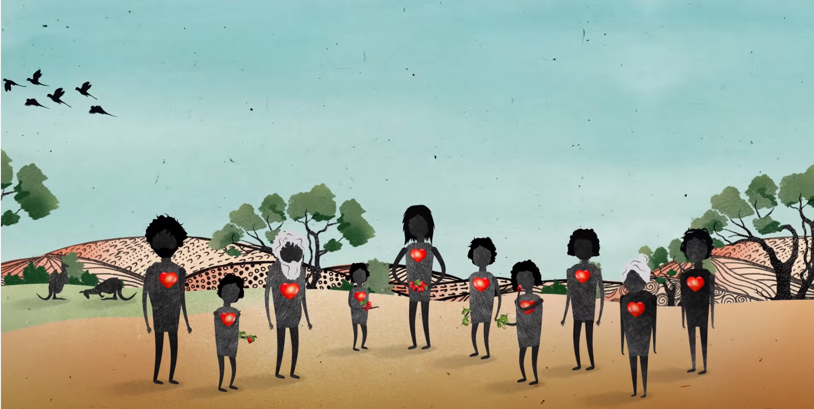

https://www.youtube.com/watch?v=vlqx8EYvRbQ

Collective Trauma
The term collective trauma describes an impact shared by a group of people of any size, including an entire society.
Situations within which collective trauma may occur include natural disasters, war, colonisation, crime and terrorist offenses, oppression or economic events.
Instances of collective trauma often result in the social fabric of a community or group being undermined and the things which provide meaning and purpose being disrupted for prolonged periods, leading to disconnection and taking away many of the things people rely on to resource themselves with to recover from adversity.
It is important to note that individual experiences and responses in the context of collective trauma may vary greatly.

Toxic Stress
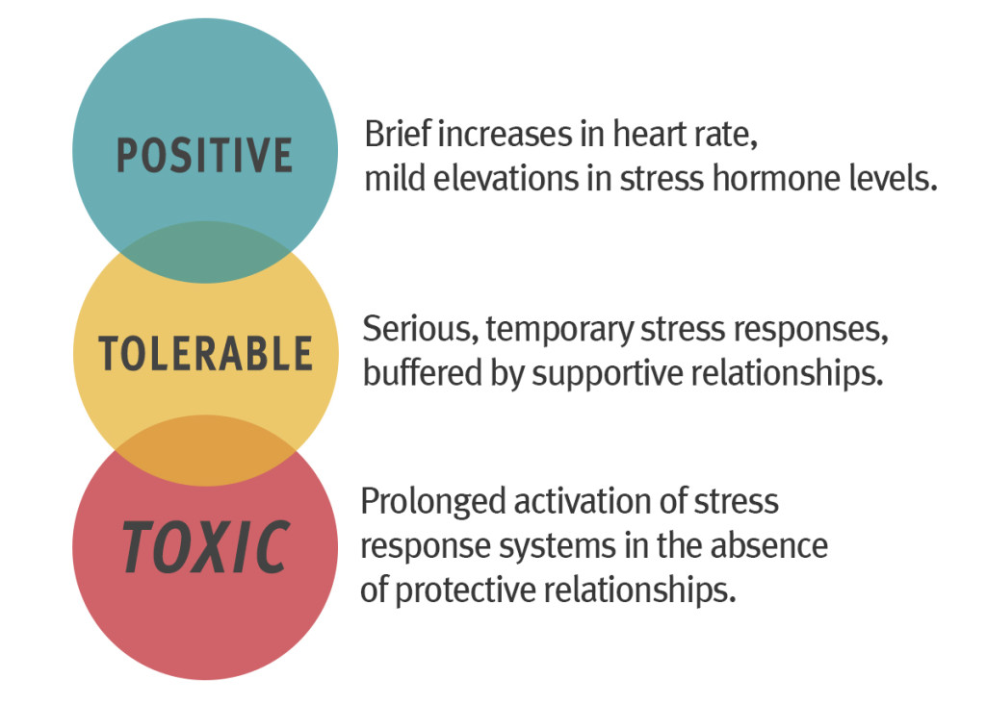

Whilst moderate, short-lived stress responses in the body can promote growth, prolonged stress becomes highly problematic. Following stressful experiences, we need time to rest and recover to return to optimal functioning. Toxic stress occurs when children experience strong, frequent and/or prolonged experiences of adversity, resulting in unrelieved activation of the body’s stress management system in the absence of effective, protective adult support. Without caring adults to buffer children from the impact of stress, these unrelenting occurrences can weaken the architecture of the developing brain, with long-term consequences for learning, behaviour, and both physical and mental health.

DEFINING TRAUMA: KEY MESSAGES

- Trauma describes the impact rather than the event, and will be unique for all individuals
- Trauma and toxic stress increase vulnerability, not resilience
- Trauma in the context of close relationships is particularly detrimental
- Very young children are more, not less, vulnerable to the impacts of trauma and toxic stress, due to their developing brains and reliance on others for safety

DEFINING TRAUMA:
REFLECTIVE QUESTIONS

What are the known traumas that the young person in your care has experienced?

Impacts of Developmental Trauma

Trauma can impact on all aspects of children’s development. Understanding these impacts is critical to identifying what support traumatised children and young people need.

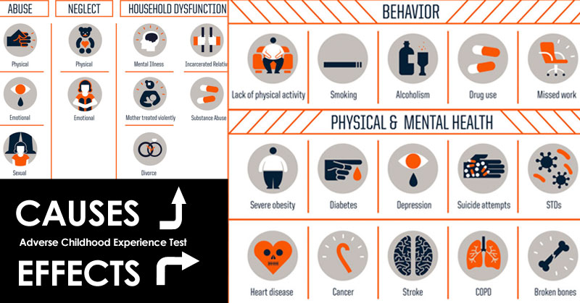

In 1995 a significant research project known as the Adverse Childhood Experiences (ACE) Study was commenced by a US health organisation and the Centre for Disease Control and Prevention. The study had over 17,000 participants and was conducted over a two year period, with long-term follow-up. The ACE study revealed a strong correlation between adverse childhood experiences (developmental trauma) and health and social problems throughout the lifespan. The study also revealed the high prevalence of adverse childhood experiences amongst the general population with almost two thirds of respondents reporting at least one. Adverse childhood experiences were found to often occur together with 40% or respondents having experienced 2 or more. Adverse childhood experiences were found to have a “dose-response” relationship with many health problems throughout life.

Watch the following TED Talk where paediatrician Nadine Burke Harris talks about ACES.
How Childhood Trauma Affects Health Across a Lifetime
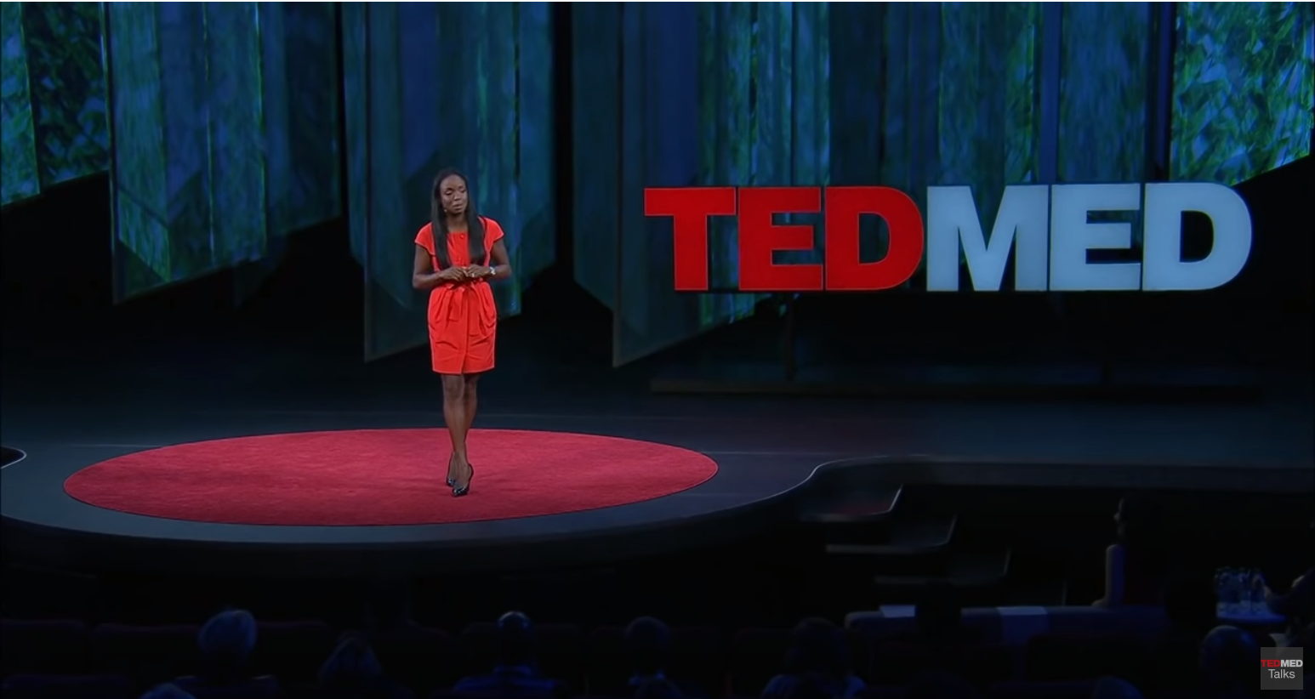
https://www.youtube.com/watch?v=uXXTLf7oouU

Trauma and Brain Development
Sequential brain development is significantly disrupted by developmental trauma and toxic stress. This often has ramifications for a child’s functioning across multiple domains. This process can begin in utero, due to either a mother’s own early childhood adversity affecting her biology, or as a result of stressful events she is exposed to during the pregnancy. Areas of the brain may be underdeveloped or poorly organised through lack of predictable, repetitive experiences. The connections between structures of the brain are made less efficient.

- Cortex goes “offline” as energy directed to survival processes
- Diminished executive functioning – reduced impulse control, problem-solving ability and reflective capacity
- Poor “top-down” integration meaning cortex has less influence on lower-brain systems

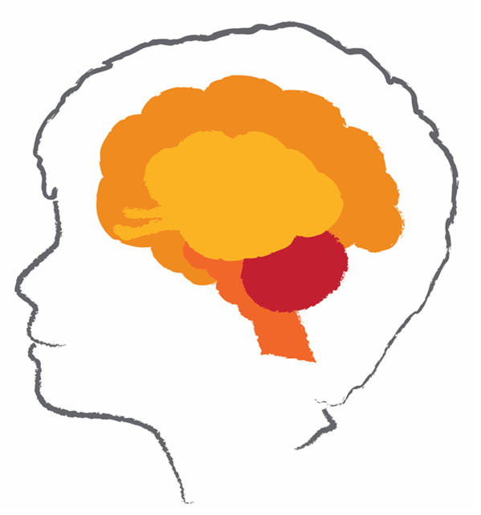
- Area can have decreased volume
- Poor motor control and coordination, clumsiness
- Delayed gross and fine motor milestones

- The amygdala is larger and over-active or switches off
- Over-developed pathways between thalamus and amygdala; under-developed pathway to cortex
- Child remains in state of high-alert and hypervigilance
- Cortisol damages the hippocampus, impacting on memory

- Increased baseline heartrate
- Dysregulation
- Sleep problems
- Shallow breathing
- Overactive response to visual threat stimuli

Horizontal integration (connection between the left and right hemispheres) will also be reduced, as the corpus callosum, (the bridge structure between the sides) has been found to be smaller and act slower.

Childhood Trauma and the Brain (UK Trauma Council)

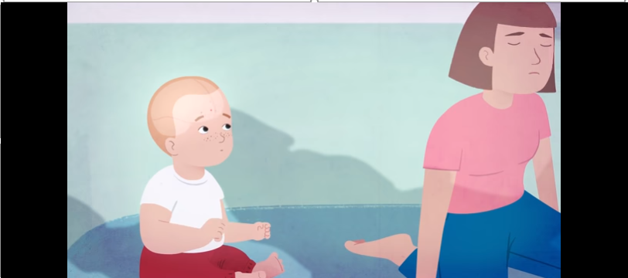

https://www.youtube.com/watch?v=xYBUY1kZpf8&t=130s

Trauma and Memory
Exposure to chronic toxic stress or complex trauma impacts the effectiveness of key brain structures to integrate the different dimensions of memory. The sensory and emotional aspects of traumatic memories are not connected to the explicit memories (the facts). When they are exposed or confronted with cues associated with the traumatic experience from their past, children and young people can be flooded with the full force of the sensory memory fragments being triggered in their present without any awareness that they are responses from their past. Traumatised children and young people are lost in time. They are not connected to their own reactions. Their present and their past are mixed up and confused. They find it difficult to make sense of what has happened to them and what continues to drive their thoughts, feelings and behaviour.

Children’s memories are in themselves a source of threats. They shut them down, do not engage with them and avoid them. As such, they do not rehearse building memories about themselves over time. Children and young people struggle to access stories about themselves and relationships. Their memories do not form the stories that they need to understand who they are, what they are good at and what relationships with others mean to them. They cannot remember examples of themselves with qualities they can own and believe in.

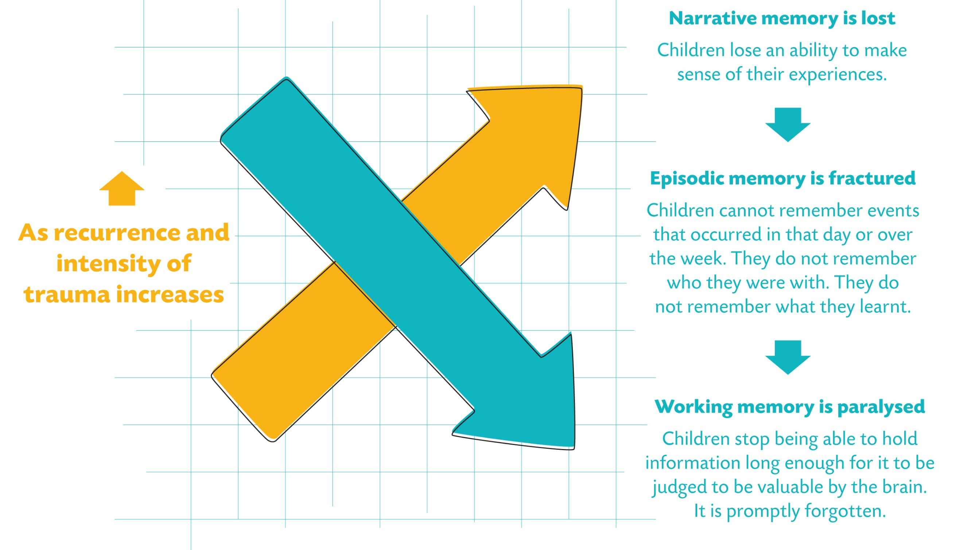

Trauma and Attention
Following experiences of developmental trauma, children’s attention becomes focused on incoming information relevant to their trauma experience (safety and survival). This results in children becoming highly vigilant to danger, which reduces their capacity to pay attention in the present moment. The child’s brain is busy scanning for danger and potential threats, all of which happens outside the child’s awareness. When it is hard for a child to pay attention to new information, this can have a significant impact on their learning across all settings, but particularly those which are unfamiliar or unpredictable. With their attention focused on survival, children may also have a reduced ability to explore and be curious about their world. They may find it hard to relax and engage in activities that other children take for granted, such as play.

Trauma and Emotion Regulation
Trauma alters children’s baseline arousal level. Trauma and toxic stress recalibrate the arousal system of children and young people, leaving it switched on all the time. Children who have experienced developmental trauma are likely to have a reduced “Window of Tolerance”. The ability of the child to process both internal and external sensory data is limited, leading to feelings of dysregulation. What others perceive as small changes or stressors will be perceived as threatening and trigger a defence response. These triggers in themselves may not be truly dangerous or threatening, but for traumatised children and young people, the best option is to stay alert to danger and consider any change, even positive change, a possible threat. Children will also have a reduced capacity to use cortical processes (i.e., higher-level, rational thinking) to calm themselves down in these situations.

In the face of perceived threat, children may present with hyper (too much) or hypo (too little) arousal.

Hyperarousal results in an action-oriented response which may be hypervigilant, impulsive, reactive, tense, defensive or destructive. It is the mobilised nervous system response of fight and flight, or active freeze.

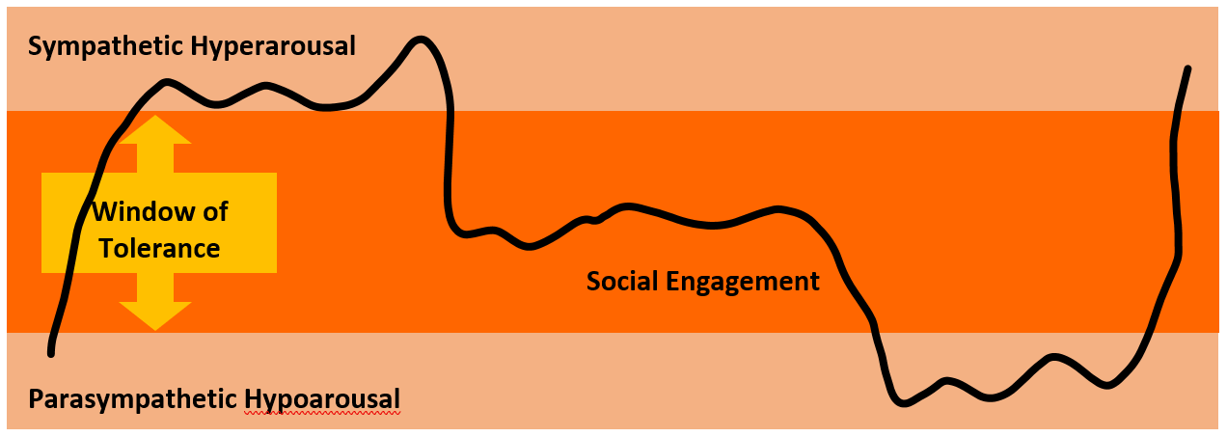

Hypoarousal results in an under-active response which may involve collapse, dissociation, a flat affect, numbness, helplessness or hopelessness. It is the immobilised nervous system response (flop/faint).

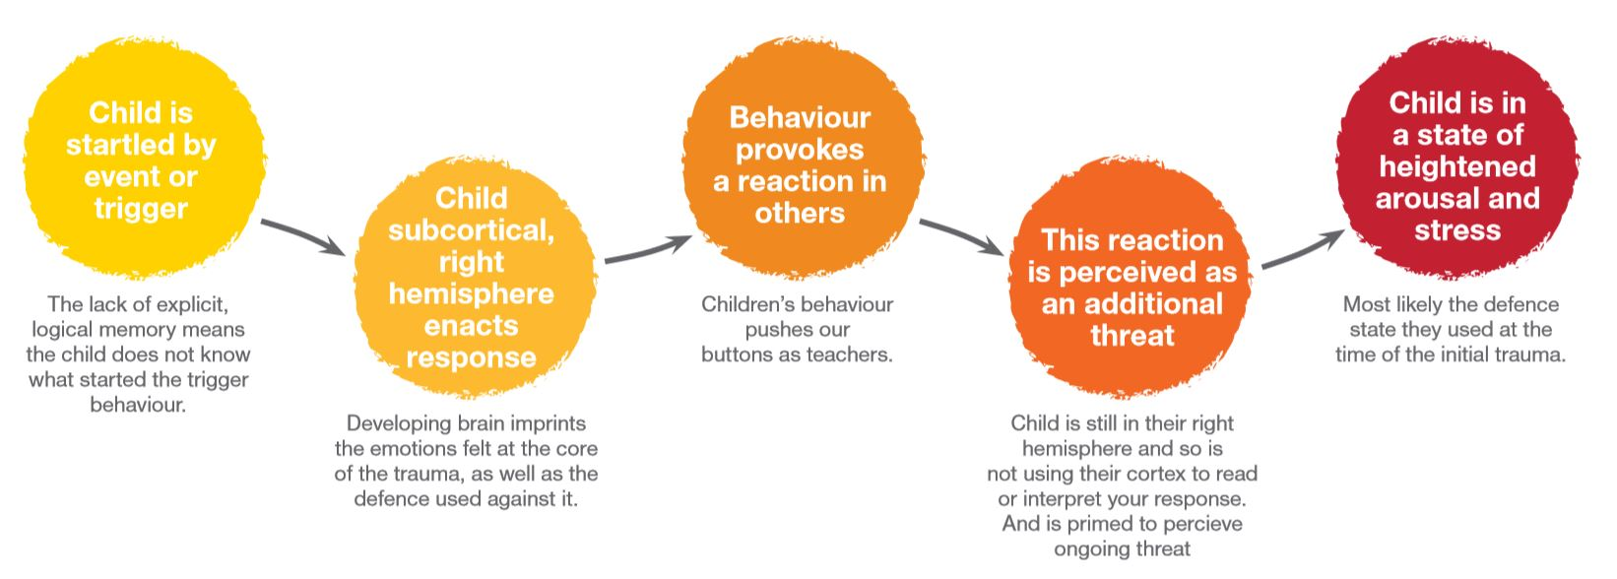

Trauma and Identity
Children who have experienced abuse and neglect are unlikely to have consistently received the relational interactions required to form a positive sense of self. Children often experience feelings of overwhelming shame and worthlessness. The may lack a sense of self-efficacy and mastery, which leads to them feeling incompetent.

Children’s difficulties connecting positively with others, their fragmented memory structures and their own confusion about their responses mean that they struggle to make sense of their experiences. They struggle to make sense of their past, feel separate from their present and have no starting point about referencing their path into the future. Children also have under-developed cortical resources which adds to the difficulty in making sense of experiences which due to their very nature are impossible to understand or rationalise.

Children’s self-perceptions are most likely to be negative due to their negative internal working models which developed early in life. Whilst they may not verbalise it, deep down children hold beliefs about themselves and the world such as “I am bad/unlovable” or “Bad things will always happen to me”
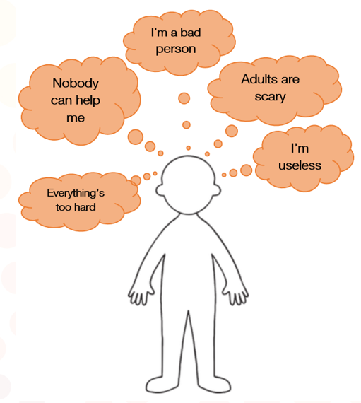
Internal Working Models

These beliefs lead to children finding it very difficult to ask for or accept help and support.
They also make it very difficult for children to integrate feelings of shame. In the context of trauma and abuse, shame often becomes core to children and young people’s identity. Children may find it difficult to accept responsibility for their own actions as they have not had relationships which have taught them to separate their mistakes from their sense of self – to translate shame into guilt.

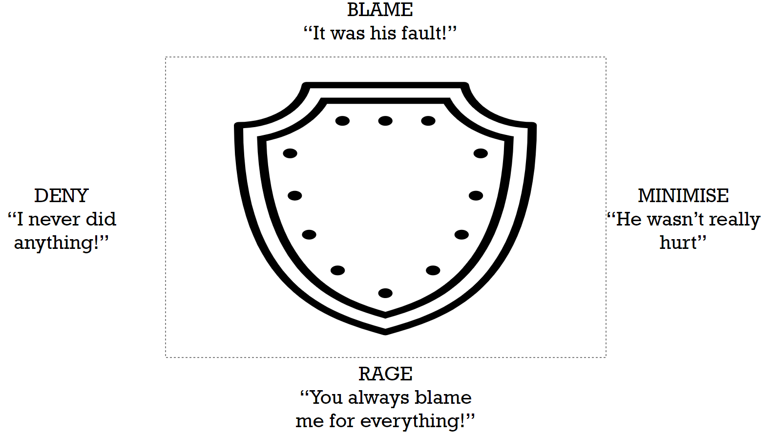

Shield Against Shame (Kim Golding)

Feelings of unresolved shame may manifest as rage, denial, blaming others or minimising.
Sometimes shame may also manifest in behaviour which seeks to appease and please others which can serve as a minimisation or denial by the child of their own needs and feelings.

Trauma and Relationships
Children who have experienced developmental trauma as a consequence of abuse and neglect have formed unhelpful templates about relationships, particularly those with caregivers and authority figures. Children are likely to approach the world with a belief that relationships are unavailable to meet their needs, are painful, misattuned and/or temporary.

The child’s nervous system is oriented to prioritise self-defence and self-reliance over their needs for social connection and comfort. This allows for survival in an environment which is relationally unsafe, unpredictable and non-nurturing. When children must rely on themselves rather than trust in their caregiver, they can enter a state of ‘blocked trust’. When children experience blocked trust they learn to resist authority and oppose caregiver influence and will avoid their caregiver as a source of potential comfort and support. Children will be unable to trust in their caregivers good intentions and have difficulty being open and able to share thoughts and feelings. They may also have a reduced ability to accurately perceive the feelings, intentions and needs of others. Sometimes children will perceive emotional expressions in others as threatening, even when they are not. Children do not trust in the unconditional support and love that’s on offer to them and may be overly self-reliant. This can lead children to develop controlling behaviours as they try to take charge of their own safety – it feels safer to be in charge than to be influenced by another.

Trauma and Culture
Through a cultural lens, subjective perceptions of trauma can sometimes be quite diverse.
Culture may influence how an individual, family or community define, interpret and assign meaning to trauma and may also impact the way in which people convey traumatic stress through behaviour, emotions and thinking.

It is also importance to recognise that children and families from cultural minority groups may face additional barriers in accessing appropriate support, which may shape the impact of trauma over the short or long term. Children who enter out-of-home-care and are placed in transcultural placements will also experience the additional trauma of disconnection from specific elements of their culture such as clothing, music, food, language and events, resulting in a loss of cultural identity.

IMPACTS OF DEVELOPMENTAL TRAUMA: KEY MESSAGES

- Trauma disrupts and undermines children’s development across all domains
- Developmental trauma can lead to long-term negative outcomes
- Trauma impairs children’s capacity to regulate their emotions and behaviour
- Trauma interferes with children’s ability to enjoy positive relationships
- Trauma diminishes children’s capacity for attention and switches off cortical functioning
- Trauma alters children’s sense of identity and evokes overwhelming shame

IMPACT OF DEVELOPMENTAL TRAUMA:
REFLECTIVE QUESTIONS

What are some of the impacts of trauma that you have observed in a child you care for?

Thinking of a child you have cared for: How do you notice trauma impacting on this child? What are the areas or domains you observe to be impacted by trauma?

References

Perry, B. Examining Child Maltreatment Through a Neurodevelopmental Lens: Clinical Applications of the Neurosequential Model of Therapeutics. June 2009, Journal of Loss and Trauma, 14(4).

Perry, B & Szalavitz, M (2006) The boy who was raised as a dog. New York: Basic Books

Porges, S. (2011) The polyvagal theory: Neurophysiological foundation of emotions, attachment, communication, self-regulation. New York: Norton

