TRAINING WORKBOOK

MODULE #4:

Therapeutic Parenting
Whenever you see this icon throughout your workbook, it is time to stop and reflect on what you have learnt so far as it relates to children you have cared for. Make some notes in the space provided.
Whenever you see this icon throughout your workbook, you will find a link to a video. Click on the link and press the CTRL button on your keyboard to play the clip.

Whenever you see this icon throughout your workbook, you are being asked to stop and take a look at one of the provided Handouts, which will provide more information about the topic.
This training requires you to think about how the material applies to specific children you have cared for. If you feel that you do not have enough experience caring for children in out of home care to respond to any of the reflective questions, a Case Study is included in the Handouts. Refer to this if needed.
HOW TO USE THIS WORKBOOK

This workbook is part of a blended training program which combines self-paced learning with direct training. After completing this workbook, you will be participate in interactive discussion sessions facilitated by a staff member from Australian Childhood Foundation’s Therapeutic Services team.

The information in this workbook is divided into modules. Accompanying the written material, we have also provided some links to short video clips which you can access on YouTube. You have also received some Handouts which accompany the written material in your workbook.

Throughout each module you will also find summaries of key messages and a small list of questions which help you to reflect on what you have learnt and how it relates to your experience caring for children.

Time will then be scheduled for you take part in a group discussion facilitated by a member of the ACF Therapeutic Services Victoria team. This will give you an opportunity to explore the concepts and ideas covered in the workbook.

PART TWO: PUTTING IT INTO PRACTICE

“If we set out to change the behaviour we are in danger of destroying the meaning which that behaviour holds”.

(Cairns 2002)

MODULE 4: THERAPEUTIC PARENTING

Defining Therapeutic Parenting

Therapeutic Parenting is the term used to describe the type of high structure, high nurture, intentional parenting that fosters feelings of safety and connectedness so that traumatised child can begin to heal and attach.

“.....the brain altered in destructive ways by trauma and neglect can also be altered in reparative healing ways. Exposing the child, over and over again, to developmentally appropriate experiences is the key. With adequate repetition, this therapeutic healing process will influence those parts of the brain altered by developmental trauma.”

(Perry 2006)

Therapeutic parenting is a model informed by research about normal development and trauma effects. Therapeutic parenting recognises how children learn and approximates the interactive learning processes these traumatised children have missed.

Therapeutic parenting begins with understanding the child and their needs. This understanding must take account of:

  - What’s happened to the child
  - How they think, feel, relate to others and behave
  - The whole of the child’s world

We often only see the behaviour. We see this as difficult, challenging, naughty even. But if we don’t understand the meaning of these behaviours then we don’t understand the child and we will be ineffective in supporting them to develop new and more adaptive ways of navigating the world. Therapeutic parenting recognizes that the child’s developmental age may be vastly different to their chronological age, and that the child is primed for survival rather than relationship.

Therapeutic parenting attends to the meanings these children have constructed from their past experiences and provides new relationship interactions that can alter their maladaptive perceptions, beliefs and understandings about themselves and others. Childhood developmental trauma causes the young person to develop a negative internal working model about themselves, relationships and the world around them. Therapeutic parenting seeks to challenge and change these templates into more positive and helpful beliefs. In order to achieve this, the child needs to have repetitive and consistent experiences which are vastly different to those experiences which shaped their original models.

Therapeutic parenting practices will be unique for every child and are guided by the ongoing observation/assessment of the child and the relationship with the carer. The Care Team assists the carer with this ongoing assessment, and in developing and implementing appropriate parenting practices. Therapeutic Parenting may involve some parenting practices which are vastly different to those within the broader community. Therapeutic parenting may require us to alter our instinctive approach to some parenting tasks and situations.

Considerations:
- Individual child’s story, including their history and trauma experiences and the impact on how they need to be parented

- The child’s developmental age and age that the trauma occurred. The age that trauma occurred and the child’s developmental age helps guide what type of intervention is required to assist in how their brain is wired. Adolescence is a very different period than younger childhood.

- Their culture – for some cultures such as Aboriginal culture, the way that parenting occurs is quite different and consists of immediate and extended family as well as the local community as the integral community of care

- Intersectionality – how different aspects of their identity can expose them to overlapping forms of discrimination and marginalisation. According to the Victorian government website some of these aspects can include:
- Aboriginality
- gender
- sexual orientation
- gender identity
- ethnicity
- colour
- nationality
- refugee or asylum seeker background
- migration or visa status
- language
- religion
- ability
- age
- mental health
- socioeconomic status
- housing status
- geographic location
- medical record
- criminal record
- All behaviour is a form of communication and it is important to try and understand what the behaviour is telling us and use our therapeutic parenting responses to understand and support that communication

Adolescence
Adolescence is a time of great change – this requires the adults to change with them. There are obvious changes due to the onset of puberty as well as possible changes in behaviour, attitude, sleep patterns and the influence of the peer group becoming most influential.
There is a sense that the child is developing into an individual with their own values, beliefs and areas of interest.
A focus on calming and nurturing is particularly important to contain risk taking behaviours within a safe environment and to curb impulse. It is not that adolescents need adults any less, it is that they need us to change with them, so our parenting approaches remain effective.

Redirecting novelty-seeking behaviour into channels that promote healthy outcomes e.g. rock climbing, surfing, ropes courses, competitions, art, music, performance, is important. Redirecting novelty seeking behaviours means that the young people can still have their biological needs met but do so in a safe manner.

Adolescents need opportunities for:
-Novelty seeking -Flexibility -Curiosity
-Exploration -Openness -Enthusiasm

In his book, Brainstorm (2014), Daniel Siegal discusses that as the adults who are supporting adolescents that we must strive to “be open to what is happening, to be receptive and responsive instead of reactive, to connect rather than correct”. This can be difficult as what they do often challenges the values and expectations of the parent. In these moments it is important to remember that these processes are normal and that what your adolescent needs the most from you is for you to be present, attuned to them and resonate with their inner world which in turn as Siegal says, provides a felt sensation of being “seen, safe, soothed and secure” which is the essence of healthy relationships and secure attachments. He says that as parents the key with adolescents is “to be open to the changes and challenges, to honour the person the adolescent is becoming through all of the many unpredictable stages and experiences this time entails” rather than trying to control who they are becoming.
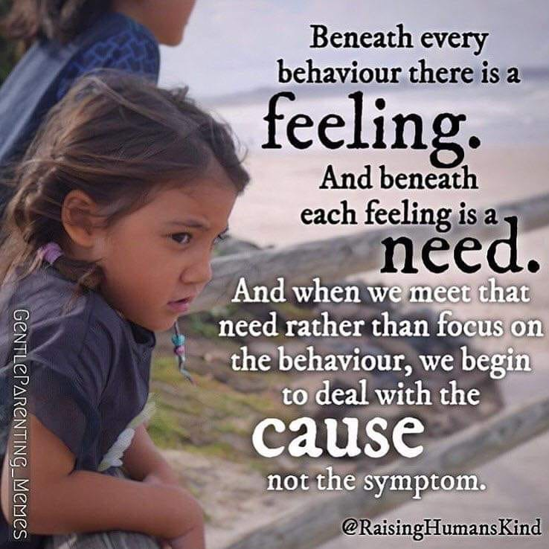

Attributes for a Therapeutic Parent

- The ability to consider the issues underlying the child’s behaviour
- The ability to acknowledge, recognise and bear witness to the child’s pain
- The skills to recognise and appropriately intervene when disturbed emotions or behaviours surface
- Self-perception, which allows recognition of one’s own response patterns to the child
- An understanding of a child’s need to process and integrate painful past experiences
- A willingness to participate in the child’s therapy and use clinical guidance when appropriate
- A willingness to work as part of the care team and to report good, bad and ugly interactions in the home
- Sufficient self-awareness to be able to seek and use personal support or therapy when needed
- A life beyond therapeutic parenting that provide enrichment and self-care to the carer
KEY MESSAGES: DEFINING THERAPEUTIC PARENTING

- Therapeutic parenting focuses on understanding the child and the meaning behind behaviour
- Therapeutic parenting provides repetitive, consistent and reparative experiences within the safety of a nurturing relationship

DEFINING THERAPEUTIC PARENTING:
REFLECTIVE QUESTIONS

What attributes of therapeutic parenting do you bring to your role as a foster carer?

Click or tap here to enter text.

What are the attributes of therapeutic parenting that you might want to develop further?

Click or tap here to enter text.

Caring for a Child Who Has Experienced Developmental Trauma

The Two Hands of Parenting

“If controlling another human being is the goal, then force is necessary. Fear, intimidation, threats, power-plays, physical pain, those are the means of control. But, if growing a healthy human is the goal, then building trusting relationships, encouraging, guiding, leading, teaching and communicating are the tools for success.”
(L.R. Knost)

Nurture & Warmth
Structure & Boundaries

Building Trust and Safety: Nurture and Warmth

For many children who have experienced developmental trauma their expectations of adults will be based on unhelpful templates formed in the context of abuse, neglect and/or toxic stress. They will perceive adults as unsafe and untrustworthy.

Nurture and Warmth involve:

- Thinking deeply about the child’s neuroception of safety
- Being available and attuned to the child’s needs
- Responding to the child’s developmental rather than chronological age
- Tolerating regression to earlier developmental stages, particularly during change or uncertainty
- Delighting in the child
- Keeping the chid “in mind”
- Seeking and creating opportunities to connect in a developmental appropriate way

Experiences of being cared for might feel unfamiliar and scary for children, which can generate an instinct to reject them. Supporting the child to develop new templates about themselves and relationships requires us to find ways of providing nurture and warmth which children can tolerate.

Structure and Boundaries: Predictability and Containment

All children need to be emotionally held (contained) by adults with structure to feel safe, but this can be particularly important for children who have experienced developmental trauma. These children may have adapted to chaotic and erratic environments and are now hypersensitive to the stress that uncertainty and change.

Structure and Boundaries involve:

- Consistent daily routines
- Boundaries and limits which are clearly explained to the child
- Giving choices
- Communicating your intentions
- Key adults involved in caregiving being on the same page
- Containment – I am strong enough to hold you, contain you, manage your emotions and behaviour

It is important to bring these into action from the beginning of a placement or relationship with a child. Otherwise the child may feel “tricked” or betrayed if their perception is that limits and expectations suddenly change once they are settled into the placement. It is also likely that children may resist or attempt to derail our attempts to provide stability, especially if it is unfamiliar (and therefore evokes anxiety).
We can accept that the child may take time to adapt to the routines and expectations whilst still consistently reinforcing what those are. “I can see you’re still learning ….”
KEY MESSAGES: TWO HANDS OF PARENTING

- Many children who have experienced developmental trauma will perceive adults as unsafe and untrustworthy.
- Parenting traumatised children requires being able to help them build new templates about relationships being able to be supportive and safe.
- Structure and boundaries through consistent, predictable routines helps to build a feeling of safety.

TWO HANDS OF PARENTING:
REFLECTIVE QUESTIONS

What are some ways that you can show nurture and warmth in non-threatening ways to a foster child in your care?

Click or tap here to enter text.

How have you implemented structure and boundaries for children in your home?

Click or tap here to enter text.

Parenting with PACE

PACE is an acronym (Playful, Accepting, Curious, Empathic) outlining a framework for both clinical therapeutic intervention and parenting. PACE is built on an understanding of the neurobiology of attachment relationships and can be purposefully used to build trust and connection. Whilst PACE can be used within all relationships, it is particularly helpful in relationships with individuals who have experienced developmental trauma, as it seeks to create the type of relational interactions children likely missed out on during infancy and early childhood. This helps children to experience safe and secure attachment relationships.

PACE is also based around the concept of intersubjectivity. Intersubjectivity describes the reciprocal relationship such as that between a parent and child, where each individual is open to the other. There is a shared experience of self, other and the world. Attachment and intersubjectivity combined increase safety and engagement as well as mutual influence. PACE is something that we do WITH rather than TO.

PACE is not aimed at changing the child, rather it is used to help the child to feel connected and better understood. This in turn builds the trust and security that is necessary for a secure base. PACE is a way of being with children rather than a technique to switch on and off.

Playfulness
- Recreates experiences of delight and joy not available to the child in infancy
- Provides child with an opportunity to experience positive emotion
- Sharing a positive experience not just with but of the child
- Activates cortical brain systems

When we parent from birth, we have the opportunity to create safety, attunement and an atmosphere of unconditional love through our joy in being with our baby. Unfortunately, the children that we are working with have often not had this experience
Playfulness allows children an opportunity to become more comfortable with positive emotion without becoming overwhelmed. The Carer can assist the child to tolerate and regulate joy and excitement.
Playfulness provides a sense of optimism; it involves sharing a positive experience not just with but of the child. It also provides an opportunity to enter the child’s world on their terms.

We may need to allow playfulness to emerge naturally in the relationship as safety increases; some children may be uncertain of your motives in using playfulness as it feels unfamiliar; they may fear being tricked or made fun of. We also need to be very careful using humour such as sarcasm which requires left-right hemisphere integration (often impaired in children who have experienced trauma). Ensure that non-verbal language (tone of voice, facial expression) matches and emphasises the playful intention of your language.

Acceptance
- Recreates experiences of unconditional positive regard not provided in infancy
- Noticing but not evaluating the child
- Demonstrating understanding for the child’s actions and the feelings which led to these
- Separating behaviour from the individual and acknowledging that the child is doing the best they can

The primary goal of acceptance is to increase safety for the child through reduction of shame.
Through acceptance the child can explore, experience and express their inner world more freely. As in mindfulness practice, acceptance is about noticing not evaluating.
When we parent from birth, we can provide children with an experience of acceptance repeatedly throughout the first year of life prior to reaching the developmental stage where limit-setting is required. This helps to internalise a sense of self as worthy and loveable prior to the relationship rupture experienced during discipline and limit-setting. We do not judge a baby’s actions as “good” or “bad”. This gets harder to do with older children but experiencing this type of unconditional acceptance remains a core need for child to be able to experience themselves as loveable.

Concern may arise that if we display an attitude of acceptance, we take away our ability to effectively address inappropriate behaviours. This can trigger anxiety based on a feeling that we will be judged on our success and skills as carers based on the degree to which our child demonstrates appropriate socialisation behaviours. When a carer accepts the behavioural choices the child makes and the feelings behind these choices, they are not necessarily accepting that they are good choices! Rather they are communicating their understanding (or desire to understand) the feelings underlying the behaviour. The use of acceptance often brings less defensiveness/opposition and increase the child’s openness to a caregiver’s limit-setting and guidance.

Curiousity
- Creating the intense fascination not experienced during infancy
- Allows a child to feel understood
- Wondering with the child about the meaning behind the behaviour and why they do the things they do
- Sometimes means making best guesses about what is going on and figuring out together
- Can be a challenge when we anticipate an answer that may feel overwhelming, or that we won’t have a solution for

When curious, we will attribute a more positive meaning to a child’s behaviour. We are able to see problems and challenges as opportunities to address the child’s vulnerabilities.
Curiosity may be experienced as uncomfortable or threatening by children who fear that if their carer sees their internal world their true “badness” will be exposed, leading to rejection.
Children may use the “Shield of Shame” to protect themselves from the intersubjective experience of their parent/carer wanting to understand their inner life. This can successfully push carers away from being curious (can trigger feelings of rejection and defensiveness in carers).

If a child rejects our curiosity, we can respond to this with acceptance. E.g. If child responds with “I don’t know” or “Leave me alone” when we try to wonder with them about something. Otherwise, we risk reinforcing the “Shield of Shame” behaviours.

Non-verbal communication such as tone of voice and facial expression is important so that the child can experience as genuinely curious about their inner world and not like they are under interrogation! “Why” questions can be used but need to be asked in a careful way. E.g. “I noticed … and I’m wondering why you think …”

It is important to be curious about the positives and not just the challenging moments. Build a sense of wonder in the child’s accomplishments.

To adopt the “not knowing” stance essential for genuine curiosity we need to be willing to accept and acknowledge that we are not “experts” who hold all the answers about the child.

Empathy
- The quality of ‘feeling with’ another person, feeling compassion for their struggles or suffering
- Empathy eventually allows the child to acknowledge deeper feelings of fear, sadness, hurt, anger, without fearing judgement
- Statements such as “I’m so sorry that happened” or “that must have been really hard” convey empathy
- Empathy can also be used to soften a child’s defences
- When a child says, ‘you don’t love me!’ it is better to respond with ‘it makes me feel really sad to hear you say you think I don’t love you’ rather than ‘yes I do!’
- Empathy can also relieve shame and is often more useful than praise, which can exacerbate shame

When an infant experiences distress, they feel under threat and their behaviour becomes goal-directed (comfort seeking). When parents respond in a manner which provides the comfort which is required, the child experiences them as available and attuned. This allows a feeling of safety to be restored. This requires that the parent is able to sit with the child’s distress until it is successfully resolved. Empathy can be viewed as the flipside of Playfulness. Whereas Playfulness helps us to enhance and regulate positive emotions, empathy helps us to reduce and regulate negative emotions.

Parents and carers may find empathy challenging through fear that it reinforces inappropriate behaviour.
Often as parents/carers we assume that our job is to give advice or to ‘fix’ problems for our children. We may offer reassurance, we may minimise or distract or engage in problem-solving when our children present as upset by something. Empathy requires us to focus on the experience of the child/young person rather than the event itself.

Attunement is at the core of empathy and requires attention to non-verbal affect matching.
In seeking to provide empathy, “less is more” verbally. Talking too much will shift the focus from an emotional one to a cognitive. We can start with general statements (e.g. “Sounds really hard”) and allow the child to define their experience with us.

Empathy may be resisted by children as it invites vulnerability which some may find challenging to tolerate. When a child anticipates evaluation, they may present as defensive to empathy. If this occurs, we can proceed gently (use acceptance and curiosity) however need to try and stay consistent with our message that we are attuned to the inner experience.

Empathy allows the child to deal with the distress which is contributing to inappropriate behaviours and also helps them to manage the shame which arises as a result of discipline. This means that they will be more capable of retaining the messages the carers are trying to give them.

Dan Hughes Quote: “When you discipline your child, add empathy not anger and it is much more likely to be successful.”

It can be challenging to empathise with the child when you are the source of the child’s distress (e.g. through limit-setting). As adults we may seek to ignore or minimise the child’s emotion as a self-protective measure. May be helpful to think of the types of interactions we would often have with a toddler. E.g. Toddler becomes upset when a behavioural limit or consequence is enforced (such as a toy packed away when it was thrown). Toddler will often seek and accept comfort from their parent even though they are cross at them.

KEY MESSAGES: PACE

- PACE (Playful, Accepting, Curious, Empathic) outlines a framework for both clinical therapeutic intervention and parenting. PACE is built on an understanding of the neurobiology of attachment relationships and can be purposefully used to build trust and connection.
- PACE is used to help the child to feel connected and better understood. This in turn builds the trust and security that is necessary for a secure base. PACE is a way of being with children rather than a technique to switch on and off.

PARENTING WITH PACE:
REFLECTIVE QUESTIONS

Describe examples of ways that you could use the attributes of PACE with a child in your care:

Playful

Click or tap here to enter text.

Accepting

Click or tap here to enter text.

Curious

Click or tap here to enter text.

Empathic

Click or tap here to enter text.

Which part/s of PACE do you think you might find the most difficult to use?

Click or tap here to enter text.

Connection Before Correction
Drawing on the Two Hands of Parenting model provides us with a helpful approach when thinking about responding to children during challenging moments. We need to ensure that we are parenting with both hands, and that we lead and conclude with interactions which reinforce the safe, trusting relationship we are seeking to establish. In this way, discipline can occur “sandwiched” between attuning to the child and repair the relationship with the child.

The Parenting Sandwich

Children who have experienced developmental trauma may present with a range of behaviours which are challenging and confusing for us as carers to understand and manage.
These behaviours are likely to occur for reasons such as:

- The child does not assume that we have good intentions (therefore does not trust that our decisions are in their best interests)
- The child is unable to integrate shame and so to uses strategies to defend against it (see “Shield Against Shame”)
- The child has a limited ability to read emotional cues from others
- The child is functioning at a baseline of high arousal with a narrow window of tolerance, and therefore become dysregulated quickly in response to small changes or challenges.

It is important to hold onto a clear understanding that discipline is a tool for teaching and learning – not punishing. It is important that whenever we experience a child demonstrating behaviour which is outside of our established boundaries and limits, we take a moment to pause and consider the reasons the behaviour might be occurring. When we take the time to ask ourselves what the feelings and needs which underly the child’s difficult or inappropriate behaviours, might be, we are much more likely to respond in a helpful way.

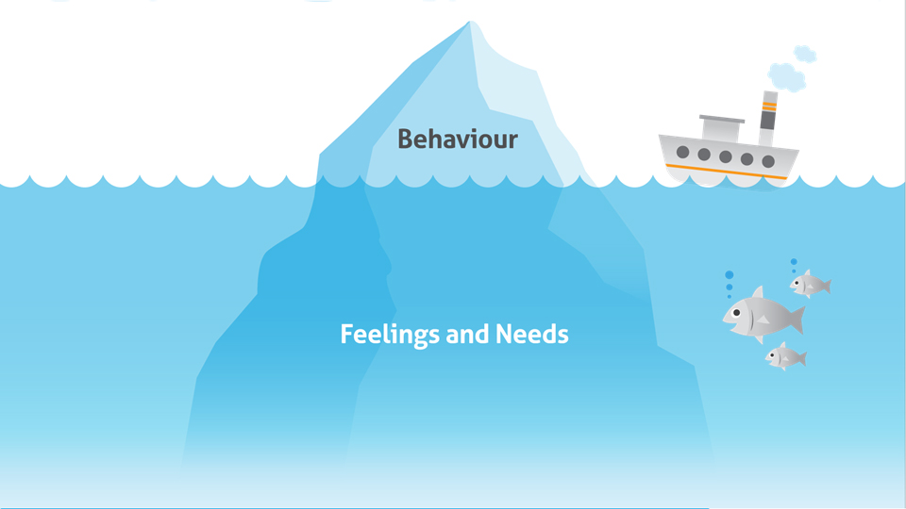

If we are struggling with our own emotional response to a child’s behaviour (anger, disappointment, fear) then it is important that we identify an appropriate strategy to manage this response, rather than channelling these feelings into how we follow up with the child. If we do not do this effectively, we may be at risk of responding with punishment rather than discipline. Punishing children will not contribute to our goal of supporting them to build new skills to handle situations better in the future, and it will also have a negative impact on our relationship.

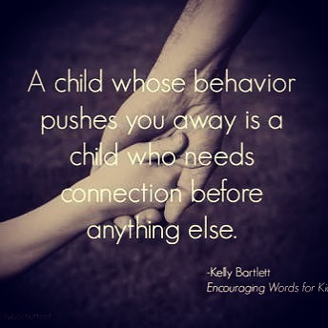

CONNECTION BEFORE CORRECTION: KEY MESSAGES

- All of our interactions with children who have experienced developmental trauma – especially those relating to boundary-setting and discipline – must occur in a way which reinforces trust and safety

- Our attempts to respond to challenging behaviours (correction) will be much more successful if the child feels understood (connected).

- By using connection before correction, children learn that we have their best interests at heart, and will become more accepting of limit-setting and our efforts to guide their behaviour.

CONNECTION BEFORE CORRECTION:
REFLECTIVE QUESTIONS

What do you understand about using discipline with children who have experienced trauma?

Click or tap here to enter text.

Co-Regulation
Children with trauma & attachment difficulties have limited capacity for self-regulation and need others to help them manage their emotions. Like a parent does for an infant or young child, carers need to play the role of the child’s “prosthetic cortex” and actively help them to identify and make-meaning of intense emotional experiences.

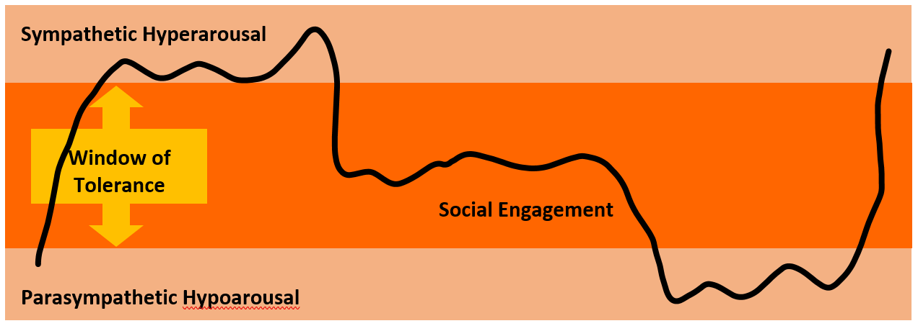

For example: Imagine a child has a tantrum after being told there will be no more iPad time today. They scream and kick at the toys on the floor when you suggest they play with something else. One possible parenting response to this behaviour may be to send the child to their bedroom to “calm down”. If the tantrum goes on for a long time or the child’s behaviour becomes especially difficult, we may even tell them they are to go to “time out”. However, for many children who have experienced trauma, time out can often replicate their earlier experiences of rejection/abandonment. It also means that they are now alone with their big feelings, which they have not yet learnt how to effectively manage. Not only does this mean that the child’s distress and difficult behaviour is likely to continue, it also means there is very little possibility that the child will learn anything helpful through the time out. On the other hand, keeping the child close to a trusted adult when they are upset, unsettled or stressed (including when their behaviour is very difficult) will increase the child’s feelings of security and promote attachment. Rather than send the child to their room for time out the carer might instead use “time in” and say to the child “It’s really hard for you right now to (understand why you can’t use the iPad).…come sit next to me & I will help you with your big feelings”. We cannot underestimate the impact of simply “being with” children when they are experiencing big emotions.
When a child is dysregulated & struggling to manage an intense emotion, (either positive or negative) carers can assist to co-regulate affect through matching the vitality of the child’s affect. Match the intensity of the child’s emotion (noise & energy level) while reflecting the child’s feelings. After paralleling this intensity, begin to change your energy and volume as you talk and soothe. The child will follow you (up or down) the energy intensity until they can be comforted in other ways.

For effective co-regulation it is important to understand the child’s unique trauma-based responses. This will develop over time from careful observation, curiousity and reflection (with the child and also with the care team).
Children who tend towards a hyperaroused or mobilised response (fight or flight) will need reduced stimulation and access to soothing activities and environments. Children who tend towards a hypoaroused or immobilised response will require increased stimulation and access to alerting activities and environments. All children will require opportunities for safe connection. Some children may shift between hyper and hypo arousal and it is important to carefully observe and respond to the child’s state at the time.

CO-REGULATION: KEY MESSAGES

- Children who have experienced trauma have a reduced ability to regulate their own feelings and behaviours
- They may rely on regulation strategies which are no longer helpful.
- The child-carer relationship is utilised to help the child manage their emotions
- Consistent co-regulation supports children to develop skills is self-regulation

CO-REGULATION:
REFLECTIVE QUESTIONS

What is one way you could help a child in your care to co-regulate when they are presenting as hyper aroused?
Click or tap here to enter text.

What is something you might do when a child is presenting as hypo aroused instead?
Click or tap here to enter text.

Therapeutic Consequences
Sometimes we may feel it is necessary or helpful to follow up challenging or inappropriate behaviours with a consequence. In these moments, it is important that we use consequences in a way that supports the child to build their capacity to manage the situation better next time, rather than in a way that reinforces their existing vulnerabilities. Consequences which are not purposefully chosen to be therapeutic may unintentionally reinforce the child’s unhelp internal working models or overwhelming shame. Traditional parenting approaches which focus on rewarding good behaviour and providing a negative consequence for undesired behaviours will often have the unintended result of increasing anxiety in children who have experienced developmental trauma. This is because these children do not hold an understanding that the rewards and consequences are focused on their behaviour and that they are loved unconditionally. They interpret consequences as a message that they are not good enough and that the relationship with their carer is unreliable. Because of this, consequence and rewards will often have the opposite effect to what was desired, and may increase challenging behaviour which is driven by anxiety and fear.

Children do need support with their behaviour but it must occur in an environment that attends to their regulation of emotions and their ability to connect with others. When we use the relationship to support children’s behaviour, we create an opportunity to utilise collaborative consequences, where adults support children to make amends for their actions.

Therapeutic consequences may consist of:
- Natural consequences: no intervention needed by adults / others. Most useful for learning
- Logical consequences: connected closely to action. Next most useful for learning.
- Reflective conversations

Example:
Child throws their meal at the wall.
- Natural consequence: their food is now on the wall / floor, and they do not have any food.
- Logical consequence: child has to help clean this up, child has toast for tea, child has to eat from a plastic plate next time.
- Unrelated Punishment: no TV for a week.

When using therapeutic consequences, timing is important. Generally speaking, the greater the proximity of the consequence to the behaviour, the more likely a child is to connect the two events. However, it must be noted that children who have experienced developmental trauma generally display an under-developed capacity for cause and effect thinking, because of the unpredictable nature of previous environments. For natural or logical consequences to be effective, children will first require support to regulate. For this reason it is important that we keep the principle of “Connection before Correction” in mind and display an attitude of PACE when we deem that a consequence is appropriate. This means that we continue to interact with children in a way that supports co-regulation and communicates empathy, curiousity and acceptance (of the child, even if the behaviour is outside of established limits). As soon as possible, we can also use playfulness to return to a relaxed and warm atmosphere in the home.

Some helpful questions for us to reflect on when considering appropriate consequences are:
- Will this teach the child what to become, or what to fear?
- Will this emotionally damage the child or my relationship with them?
- Is this response supporting them to learn about real-life consequences for their actions, or is this teaching them about punishments that only I will impose?

In the Collaborative Proactive Solutions model developed by Dr Ross Greene the premise is that challenging behaviour occurs when the demands and expectations being placed on a child exceed the child’s capacity to respond adaptively, in other words “Kids do well if they can”. Therefore, it is important to understand what the potential underlying skill deficit is and target that rather than just setting a consequence that does not teach that.
THERAPEUTIC CONSEQUENCES: KEY MESSAGES

- Traditional approaches to managing behaviour, such as rewards and consequences, can create additional anxiety and stress for children who have experienced developmental trauma.
- Therapeutic consequences are intentionally designed to teach, change or shape behaviour.
- Therapeutic consequences encourage reflection about what has gone wrong
- Therapeutic consequences prioritise the carer-child connection
- Therapeutic consequences are implemented with empathy and understanding

THERAPEUTIC CONSEQUENCES:
REFLECTIVE QUESTIONS

Can you think of an example of a therapeutic consequence for a behaviour a child in your care has demonstrated?

Click or tap here to enter text.

How easy or difficult might it be for you to adapt your parenting approach to use therapeutic consequences rather than traditional consequences?

Click or tap here to enter text.

Rupture and Repair

Relational ruptures occur when there is a break in the connection between child and caregiver. Ruptures are a regular and inevitable occurrence in all close relationships and occur regularly in healthy and secure attachment relationships between parents and children. Ruptures in the context of caring for a child who has experienced developmental trauma may occur with more frequency and more intensity. This occurs for several reasons, including the child’s difficulty tolerating limit-setting (which evokes shame); the child’s internal working models (which anticipate and perceive negative responses from adults) and child’s reduced capacity for emotional and behavioural regulation. In the context of out of home care, it is also important to acknowledge that even in long-term placement, children and carers are likely continuing to work on developing attunement and intersubjectivity within a relationship that does not have the intense shared history of a normative biological parent-child dyad. Whilst ruptures are difficult for all involved, they create an opportunity to engage the child in the follow up process of repair. By repairing the relationship, we support children to integrate feelings of shame associated with what has happened, and to receive a clear message that the relationship is ok.

Following a relational rupture, it is necessary for us to pause and consider – “How do I let the child know that our relationship is still ok?” Or in the event that the child has experienced a rupture within another relationship – “Do they need help to repair their relationship with others?”

Repair can look different depending on the child / young person however it should provide a chance to talk about what happened and the impacts of this (within the child’s reflective and language capacities).

Repair will require adults to take responsibility for getting the relationship back on track – this will be too overwhelming for the child to initiate. This does not mean that adults take responsibility for the event or misunderstanding. For repair to be successful, adults will need to remain calm and regulated and have reflected on their own emotional response to the event and their role in the rupture. This will support us to communicate to the child our intentions and to acknowledge anything we could do differently next time. The child experiences that adults can be accountable for their actions (something they may not have been able to experience in other relationships) and this increases their capacity to develop this themselves.
RUPTURE AND REPAIR: KEY MESSAGES

- Relational ruptures are inevitable and normal
- Repair needs to be initiated and led by adults
- Repair lets the child know they are still loved, valued and the relationship is not broken or damaged
- Repair challenges children’s unhelpful internal working models and reinforces security and trust.

RUPTURE AND REPAIR:
REFLECTIVE QUESTIONS

Describe one way you could let a child in your care know that their relationship with you is ok even after a difficult moment.

Click or tap here to enter text.

What might make it difficult for a carer to initiate repair with a child following a challenging moment?

Click or tap here to enter text.

What do you think it might be like for a child who has experienced trauma when repair doesn’t occur?

Click or tap here to enter text.

Phases of Care

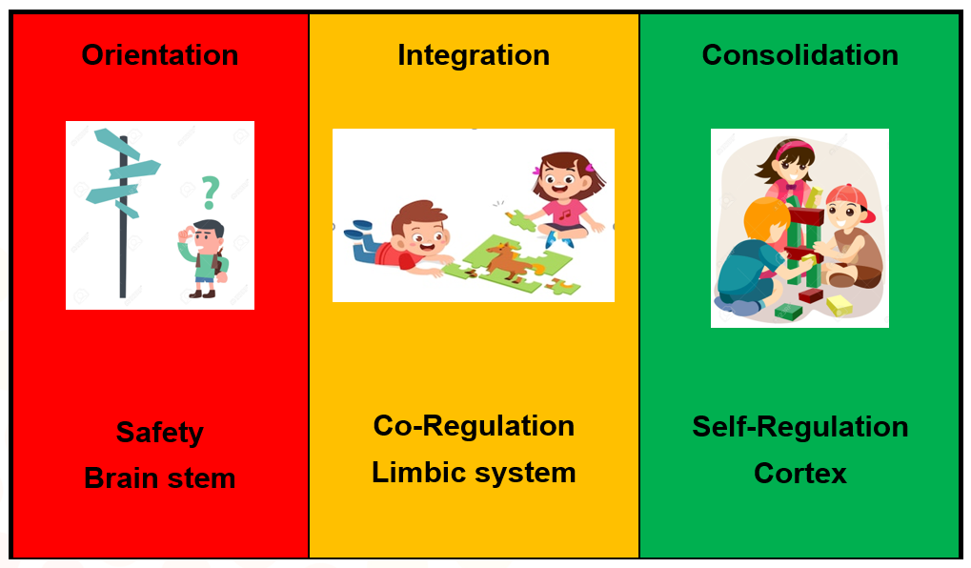

Within a therapeutic care context, a child’s process of healing moves through several, clearly identifiable stages or phases. We need to consider what children’s needs are at each phase of recovery and change, and what carers and the Care Team needs to provide to promote the child’s successful progression through each phase.

Movement through the phases is often not unidirectional. As such, the child and care context must be frequently reassessed. As the child progresses, each new stage of recovery may destabilise and produce new terrors. There then needs to be a new period of grounding and stabilising for the child to re-establish their sense of safety and assurance that they will not be overwhelmed. Sometimes a child may regress to an earlier stage if a major event occurs e.g. death of birth parent, changes to court orders or changes to a birth mother’s circumstances such as marriage, pregnancy etc. The length of these relapses may be difficult to predict. It is necessary for carers to understand though that the relapses are temporary and will last until the child feels emotionally safe to return to his/her prior place in the recovery process. It is the Care Team’s responsibility to be cognisant of these possibilities and prepare carers for them.

PHASES OF CARE:
REFLECTIVE QUESTIONS
PHASES OF CARE: KEY MESSAGES

- The Phases of Care framework assist us to focus intervention, to be realistic and purposeful
- It allows us to not have to do everything at once. Caring for a traumatized child can be overwhelming; phased care approach reminds us to keep our focus specific and realistic.
- The Phases of Care are not unidirectional – movement both forward and backwards is likely

What is something you could do or have done with a child to support the recovery process at each phase?

Phase One - Orientation/Safety

Click or tap here to enter text.

Phase Two - Integration/Reconstruction

Click or tap here to enter text.

Phase Three - Consolidation/Placement integration

Click or tap here to enter text.

Parenting in the Moment

Kim Golding developed the following 7 stage model for putting the different aspects of therapeutic parenting together. This model can serve as a reminder for us of the different components required for us to respond to children in a way which is trauma-informed. It can be particularly helpful when we encounter challenging moments. It is a guide and not intended to be applied rigidly – you may find yourself going back and forward between stages at times.

A challenging moment might be…a child’s tantrum, returning from access visits, getting ready for a respite weekend, many moments within adolescence or oppositional behaviour. As we have learnt, if the child perceives they are unsafe (even if they are not) then their body will react in the fight, flight, freeze responses. This can look like some very difficult to manage behaviours at time including physical aggression, lying, running away or hoarding food. Challenging moments can occur at any stage throughout the child’s recovery process. The way in which challenging moments are responded to can make a big difference in helping the child to develop a secure base.

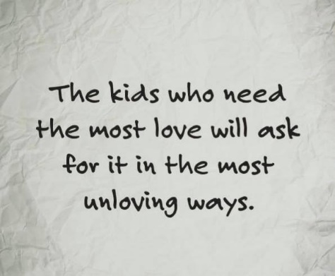

A key component of therapeutic parenting in challenging moments is our ability to notice and manage our own emotions and to be aware of how these can influence our responses to our child’s behaviour.

Watch “Being With and Shark Music”
https://www.youtube.com/watch?v=Vy3EwAQ0lwo

NOTICE
What is happening, do I need to respond? Do I need to take any immediate steps to ensure everyone keeps safe?

IMPACT ON SELF
How am I affected right now? Am I regulated? Can I stay open and engaged with the child? Am I becoming irritated, angry, anxious, defensive? Do I feel useless? Do I need a break?

REGULATE OR REFLECT
What do I need to provide to the child? Sensory or emotional regulation? Is child ready/able to reflect on the experience with my help? Is the child’s “thinking-brain” (cortex) on-line or are they in their “feeling brain” (limbic)? Use Acceptance and Empathy

CURIOUSITY
Gently explore what is happening in the child’s internal world. Use non-verbal communication such as tone of voice and facial expression to demonstrate your curiousity.

CONNECTION
Use Acceptance and Empathy to promote meaning making. Explore the reasons underlying the behaviour. How do I let the child know that I get it (or I’m trying my very best to get it)?

RESPOND
Decide on a follow on. Do I need to do anything further for or with the child? For example, problem-solving, consequence, change to structure and supervision.

It is important to acknowledge that for many of us this approach may feel like “taking the long road”. In traditional parenting approaches we often go from Noticing children’s behaviour straight to Responding without visiting any of the stages in between. When we do this we miss out on the opportunity to be curious about not only the child’s underlying feelings and needs but also our own reactions and responses.

PARENTING IN THE MOMENT: KEY MESSAGES

- Through purposeful responses we can support children to recover from trauma
- Care and interventions for children impacted by trauma must be informed by our understanding of child development, neurobiology and attachment
- Relationships are the most influential resource in supporting healing
- Caring for children impacted by children will in turn impact upon us
- Self-care and good support are essential for sustaining effective therapeutic parenting

PUTTING IT ALL TOGETHER:
REFLECTIVE QUESTIONS

Which of the 7 parenting in the moment stages do you think you would find the most difficult and why?

Click or tap here to enter text.

What kind of challenging moments and behaviours do you think would be the most difficult for you and why?

Click or tap here to enter text.

What will you need from the care team to support you with this?

Click or tap here to enter text.

References

Cairns, K. (2002) Attachment, Trauma and Resilience: Therapeutic Caring for Children

Department for Health and Human Services (2015) Aboriginal Therapeutic Home-Based Care Program and Funding Guidelines

The Circle Program: An Evaluation of a Therapeutic Approach to Foster Care (2012)

Golding, Kim (2015) Parenting in the Moment

Hughes, D & Baylin, J. (2012) Brain-Based Parenting

Knost, L.R. (2013) The Gentle Parent: Positive, Practical, Effective Discipline

https://drrossgreene.com

