TRAINING WORKBOOK

MODULE #5:

Systems Around the Child
Whenever you see this icon throughout your workbook, it is time to stop and reflect on what you have learnt so far as it relates to children you have cared for. Make some notes in the space provided.
Whenever you see this icon throughout your workbook, you will find a link to a video. Click on the link and press the CTRL button on your keyboard to play the clip.

Whenever you see this icon throughout your workbook, you are being asked to stop and take a look at one of the provided Handouts, which will provide more information about the topic.
This training requires you to think about how the material applies to specific children you have cared for. If you feel that you do not have enough experience caring for children in out of home care to respond to any of the reflective questions, a Case Study is included in the Handouts. Refer to this if needed.
HOW TO USE THIS WORKBOOK

This workbook is part of a blended training program which combines self-paced learning with direct training. After completing this workbook, you will be participate in interactive discussion sessions facilitated by a staff member from Australian Childhood Foundation’s Therapeutic Services team.

The information in this workbook is divided into modules. Accompanying the written material, we have also provided some links to short video clips which you can access on YouTube. You have also received some Handouts which accompany the written material in your workbook.

Throughout each module you will also find summaries of key messages and a small list of questions which help you to reflect on what you have learnt and how it relates to your experience caring for children.

Time will then be scheduled for you take part in a group discussion facilitated by a member of the ACF Therapeutic Services Victoria team. This will give you an opportunity to explore the concepts and ideas covered in the workbook.

MODULE 5: THE SYSTEM AROUND THE CHILD

What is a Systems Approach?

- Traumatised children and their families are often involved with multiple service systems.
- Collaboration enables all helping professionals to view the child as a whole person, thus preventing potentially competing priorities.
- Collaborative practice provides a buffer and a mechanism to process the difficult emotions and reactions that are evoked in our work with traumatized children.
- Without healthy collaboration, fears and anxieties get pushed around the system.
- Collaborative approaches recognise complex and interlinked nature of issues for children and families and are better able to address complexity through interlinked interventions (Winkworth& McArthur, 2007).

Therapeutic models of care require a multi-systemic, consistent and holistic approach across the range of environments in which the child or young person lives. Interventions are most successful when those caring for the child, support networks and professionals enact collaborative and intersecting functions that can achieve protective, reparative and restorative objectives for children.

Multi-agency working is where practitioners from more than one agency work together jointly sharing aims, information, tasks and responsibilities to provide an integrated response to children and young people and their carers who have suffered trauma and abuse. Multi-agency working involves the joint planning and delivery of coordinated services that are responsive to children and young people and their carer’s changing needs.

Challenges of working within systems:

- Ensuring the child’s voice is heard
- Individual agency roles and priorities can differ
- Differing agency priorities and agendas
- Caseloads / work loads of professionals
- Staff turnover
- Reactiveness versus proactiveness
- Multiple perspectives in decision making
- Court systems / court orders and legalities / guardianship

Positives of working with systems:
- Support with advocacy for the child’s best interests
- Support for carers from someone external to household
- Shared holding of risk
- Shared responsibility
- A lot more support within therapeutic fostering
- Therapeutic influence
- Opportunity to reflect
- Multiple perspectives on decision making - “It takes a village to raise a child”

Trauma Informed Systems

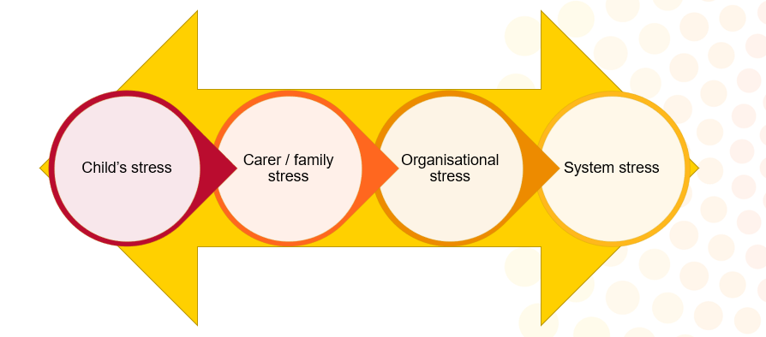

Trauma Informed Systems understand:
- The impact of childhood trauma on the children served by that system
- How the system can help mitigate the impact of trauma or can add new traumatic experiences
- The impact of trauma on all those within the child’s system
- The impact of vicarious trauma on those working with the child
- Trauma shapes the culture of child serving systems the same way trauma shapes the world view of child victims
- How to translate trauma-related knowledge into meaningful action, policy and practice changes
- Actions that can be taken at all levels of the system to make meaningful use of that understanding to make it better for the children, families, and the workforce.

An integrated trauma informed system has:
- A broader perspective
- Raised awareness of the needs of children and young people
- Reduced levels of stress
- Increased morale
- Less isolation
- Safer practice and knowledge that the risk was reduced
- Felt part of a network

It takes a village…
Both children and their primary carers require a ‘village’ of support to mirror the support patterns of the general population.
The care team helps to build an extended family around the child
Sources of mirror family members:
- Child’s birth family
- Child’s existing relationships
- Carer’s extended family, neighbourhood and existing networks
- New or respite carers

The care team

The care team has the responsibility for sharing the therapeutic parenting of a child in out of home care. The role of the care team is to together support the child’s learning, development and growth as well as their healing from trauma and the building of secure attachment. The care team has the authority and responsibility for key decisions that are usually made by parents alone.

The concept and requirements of a care team recognise that to ensure the child’s best interests are protected and promoted many issues, decisions and actions require the combined knowledge of all care team members. The care team ensures that relevant information is considered and aims to achieve the best possible outcomes for the child.
It is acknowledged that the carer carries out the vast majority of the day-to-day parenting tasks. In this, carers require support from all members of the care team in order to achieve the goals of the placement. The care team meets on a planned and regular basis to share information, assess the child’s needs, plan, and make decisions.

Practitioners cannot be effective for these children and young people if they remain in isolation from each other. The Care Team is a forum in which the separate elements of key practitioners, parent/carer and older child can stand in interaction with each other to produce outcomes that are greater than the sum of the parts. In the care team system the child’s wholeness is recognized and honoured with a whole approach.
At times there may be a good reason for parents not to participate in the Care Team – e.g., safety concerns, parent’s illness meaning they are unable to contribute, or sometimes they may be absent or unable to be located. However it is best practice for them to be included.

Carer: The central tenet of therapeutic care is the primacy of the carer: child therapeutic relationship. As was discussed in the Trauma Module, the child’s experiences of harm have typically occurred within relationships with adults in a caregiving role. Thus the carer’s role as therapeutic parent is the most critical component in the child’s recover, through providing them with reparative experiences and building more positive internal working models of relationships.
The focus becomes the carer’s ability to provide skilled therapeutic parenting - applying individually tailored techniques designed to provide the child with the best possible opportunities to grow, learn, develop and heal from the effects of abuse. To achieve this goal, carers have full access to information that is needed to provide proper care for a child and are central members of the care team.

Case manager: Your primary contact and support:
  - Supervision
  - Training
  - Information & resources
Leads and coordinates the Care Team
Ensures child’s needs are met within the placement

Therapeutic Specialist: (Circle Program Only)
Member of Care Team
Specialist expertise in child development, attachment and trauma
Completes Therapeutic Assessment and Therapeutic Care Plan
Alongside Case Manager:
  - Provides education and support to carer
  - Engages with child
May engage in therapeutic work with carer and child

Child protection worker: Share information, especially child’s history and family context
Engage with child’s birth family
Represent the legal guardian of the child
In some cases case management is contracted to the CSO – in this case the agency case manager takes the place of the child protection worker in the Care Team, and the CPP will be less intensively involved.

ACCO or Aboriginal community representative: Facilitates child’s connection to community, country and culture
Advises Care Team on culturally safe decision-making and culturally safe care
May assist in identifying potential long-term care options from within community

The child’s voice

The child or young person who is being cared for must be properly informed, consulted and their views carefully considered as part of all care team processes. This responsibility forms a part of the role of the placement worker. In some, instances this will involve the direct participation of the child in care team discussions. In deciding whether a child should participate directly in a particular care team meeting, it may be helpful to think of the care team as the parent; there are some discussions that parents have with children and others where this is not appropriate.

This participation will be different depending on what is developmentally appropriate and what the young person feels comfortable with. This might include them attending a care team meeting of school meeting, writing a letter or drawing a picture or specifically telling their worker or carer what they want the rest of the care team to know. The care team should prioritise the child’s voice and works to meet or advocate for their best interests.

KEY MESSAGES: SYSTEMS
- You’ll never know everything about the child – there will always be gaps.
- Systems are complex and can be confusing and frustrating.
- Effective Care Teams support carers to navigate the system and the child’s world.
- Both formal (professional) and informal (mirror family) systems support children to heal, grow and develop – and support carers to focus on the therapeutic care of the children.

SYSTEMS:
REFLECTIVE QUESTIONS

What have you found to be the most challenging part of working within systems?

Click or tap here to enter text.

What are some ways that you might be able to include the child’s voice within the care team?

Click or tap here to enter text.

References

Department for Health and Human Services (2015) Aboriginal Therapeutic Home-Based Care Program and Funding Guidelines

The Circle Program: An Evaluation of a Therapeutic Approach to Foster Care (2012)

Winkworth, G., & McArthur, M. (2007). Developing communities of support for vulnerable children: Shifting the focus from risk. Communities, Children and Families Australia, 3(2).

