TRAINING WORKBOOK

MODULE #6:

Caring for the Carer

Whenever you see this icon throughout your workbook, it is time to stop and reflect on what you have learnt so far as it relates to children you have cared for. Make some notes in the space provided.
Whenever you see this icon throughout your workbook, you will find a link to a video. Click on the link and press the CTRL button on your keyboard to play the clip.

Whenever you see this icon throughout your workbook, you are being asked to stop and take a look at one of the provided Handouts, which will provide more information about the topic.
This training requires you to think about how the material applies to specific children you have cared for. If you feel that you do not have enough experience caring for children in out of home care to respond to any of the reflective questions, a Case Study is included in the Handouts. Refer to this if needed.
HOW TO USE THIS WORKBOOK

This workbook is part of a blended training program which combines self-paced learning with direct training. After completing this workbook, you will be participate in interactive discussion sessions facilitated by a staff member from Australian Childhood Foundation’s Therapeutic Services team.

The information in this workbook is divided into modules. Accompanying the written material, we have also provided some links to short video clips which you can access on YouTube. You have also received some Handouts which accompany the written material in your workbook.

Throughout each module you will also find summaries of key messages and a small list of questions which help you to reflect on what you have learnt and how it relates to your experience caring for children.

Time will then be scheduled for you take part in a group discussion facilitated by a member of the ACF Therapeutic Services Victoria team. This will give you an opportunity to explore the concepts and ideas covered in the workbook.

MODULE 6: CARING FOR THE CARER

Because relationships between children who have experienced developmental trauma and their caregiving figures are so crucial in supporting recovery, it is important that we take a serious approach to understanding and looking after the emotions and wellbeing of carers.

The Parenting Brain
Parenting and caring are brain-based activities. Hughes and Baylin (2013) have identified five integrated brain systems which are required to engage fully with children.

- The Approach System – ability to get close to the child without becoming defensive
- Reward System – ability to enjoy interacting with the child
- Child-Reading System – ability to understand the mind of the child
- Meaning-Making System – ability to construct social narratives based on experiences with the child and to make sense of our social life
- Parental Executive Function – ability to regulate interpersonal conflicts between approach and avoidance, pro-social and defensive reactions
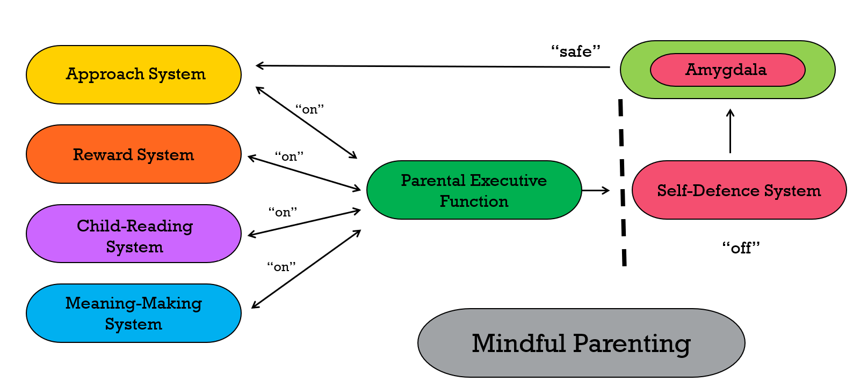

When parents and children are attuned, emotionally close and securely attached, the neurotransmitters oxytocin and dopamine are released into the parents’ limbic region, activating the pleasure and reward systems in the left hemisphere. The parent/carer experiences calm, loving and gratifying feelings and can rely on the higher brain centres for emotional regulation, empathy and self-awareness. This neurobiological state supports positive parent-child relationships.

Blocked Care

“I need to know that you really meant it when you said that I can stay here”

Blocked Care is a term used when a parent or carer’s brain’s integrated parenting systems is compromised, and therefore their capacity to nurture a child is supressed. Blocked Care can impact biological parents as well as non-biological parent-figures such as foster or kinship carers or other significant adults such as childcare workers or teachers.

In the foster care space, the risk of blocked care is often related to the difficulty that children experience responding to and reciprocating the warmth and love they are offered by carers. The impacts of developmental trauma mean that some children are simply not easy to care for. Due to their own internal working models and relational templates, children may respond with rejection, defiance, anger and controlling behaviours. When this happens repeatedly, the carer’s brain system can go into a stress response and survival mode of its own. This activates subcortical (downstairs) brain regions which are defensive and self-protective and deactivates the balanced and mature responses of the cerebral cortex (upstairs brain).

“Feel-good” neurochemicals, dopamine and oxytocin, associated with feelings of reward and bonding subsequently become blocked, and neurochemicals associated with feelings of anxiety and threat (cortisol and epinephrine) are released. This leads to a reduction in feelings of warmth and care toward the child, and an increase in avoidance and fear. It also reduces our ability to think rationally or creatively about problems.

Carers may find themselves experiencing feelings of frustration and hopelessness and find it increasingly difficult to understand the child’s feelings and needs. This is not because they no longer care about the child but because they no longer feel empathetic towards them. Carers learn to protect themselves from the child’s negative responses to their caregiving by withdrawing and becoming more distant.

In the context of blocked care, carers may also become more hypervigilant to signs of rejection or anger in the child’s verbal and non-verbal communication. This can lead to the carer being quickly triggered into a defensive response, sometimes without even know why.

Blocked care:

- Happens to many carers
- Is related to stress
- Is influenced by our own past experiences of relationships
- Is caring in survival mode

“Our growing understanding of attachment and the processes that shape the parenting brain are opening new possibilities for helping stressed-out parents who are turned off to their own children
(Hughes and Baylin, 2013)

As a carer feels rejected by their child, they may develop negative thoughts about themselves, the child and the whole task of parenting and looking after them.

We often defend ourselves against the feelings of shame and hopeless by tuning out the child’s needs. This prevents us from reflecting positively on our role as a carer, from recalling positive moments with our child or from developing new narratives about the child and our relationship with them.

The concept of Blocked Care helps us to understand that insensitive parenting is often linked to stress and deficiencies in key brain systems, including the dopamine and oxytocin circuitry.
Carers may want to like and enjoy their children but they don’t know how to activate the good chemistry that would enable them to do so. Blocked Care is not a sign that someone is not equipped to be a carer, but it may indicate that they need more support to understand the child they are caring for and to look after themselves.

BLOCKED CARE: KEY MESSAGES

- Blocked Care describes a state where a parent or carer’s capacity to provide nurture is suppressed or “turned-off”
- Blocked Care is a normative brain-based response to parenting in challenging circumstances – it does not mean that some is a “bad” parent or carer
- Good self-care practice may reduce vulnerability to experiencing Blocked Care
- Blocked Care can be resolved with support from the Care Team

BLOCKED CARE:
REFLECTIVE QUESTIONS

Have you ever experienced Blocked Care whilst looking after a child before? If so, what was it like?

Click or tap here to enter text.

What might you say to another foster carer who told you they were experiencing something which sounded like Blocked Care?

Click or tap here to enter text.

Self-Care for Carers

The relationship between the child and carer is one of the primary vehicles for healing in therapeutic care and the child’s experience and behaviour can evoke powerful feelings in you. It is important to take care of yourself in this demanding and complex role and to understand your feelings and reactions.

Self-care is not an emergency response plan to be activated when stress becomes overwhelming. It is not about doing more or adding more tasks to an already overflowing to-do list, nor is it about being ‘selfish’. Self-care is an intentional way of living by which our values, attitudes and actions are integrated into our day-to-day routines. It is as much about “letting go” as it is about taking action.

To be able to provide care to others which relies on the use of self and the relationship that you have with the child, you first require adequate nurture and sustenance yourself.
There is no correct formula for self-care. Each “self-care plan” will be unique and change over time. Ultimately, we must listen well to our own bodies, hearts, and minds, as well as to the counsel of trusted friends, as we seek resiliency and renewal in our lives and caring.

There are 4 R’s to consider when thinking about self-care, and they are reflection, regulation, relaxation and resources.

Reflection
Being reflective can assist to better understand the child, and yourself. It can increase your ability to provide thoughtful responses that are healing to the child and reduce the risk of responding from your own anxiety or becoming crisis driven.

Reflective questions to ask of yourself might include:
- Understanding the child’s behaviour (what is their behaviour telling me?)
- What are my thoughts/feelings (my ability to self-regulate)?
- What were my responses in relation to this behaviour?
- Where is our relationship at (carer-child relationship)?
- What if anything might I do differently next time?

Regulation
When caring for and working with children with trauma and attachment disruption, feelings can often be stirred up within us. It is important to be aware that their dysregulated emotions might trigger similar emotions in you. What they need in these moments is your calm, so that you can co-regulate them. We need to recognise how our own history can impact on our current relationships and interpretation of events. Children are sensitive to our reactions and emotions and often experience these as something about them.

Notice when it was difficult to respond to the child’s needs because of your own feelings or reactions to the situation. What was the child doing, what were you feeling, how did you respond?

Explore ways you can manage your own feelings, so that you are still able to respond to the child’s needs. Things that might assist are:
- using relaxation strategies (e.g., breathing);
- not taking the behaviour personally;
- mental reminders (“their rejection of me is letting me know that someone must have rejected them”; “their behaviour is really telling me they need me”); or
- taking a short break- if available, can you hand over the role to the other parent?

Relaxation
We need to acknowledge that caring for abused and neglected children can be stressful and that stress impacts on different people in different ways. Carers need to attend to their own needs in order to provide the high level of care these children require and find ways to be able to relax. Think about ways that you can build relaxation into your day.

Resources
It is also important to develop and maintain a support network. This may include a central supportive relationship with another adult, maintaining connections with family & friends and building relationships with other carers of children with trauma and attachment difficulties (e.g. joining a support group).

The care team provides an opportunity not only to share information, but to also share feelings. When individuals are out of ideas and energy the combination of expertise and support in a Care Team can help each of us get things into perspective, to revitalise and re-energise. Caring for hurt children in a complex system where much is outside our control requires the combined thinking and action of a team.

SELF-CARE: KEY MESSAGES

- We need to acknowledge that caring for abused and neglected children can be stressful and that stress impacts on different people in different ways.
- Carers need to attend to their own needs in order to provide the high level of care these children require
- Be patient with the child’s progress and with yourself
- Take care of yourself
- Use the 4 R’s: Reflection, Regulation, Relaxation, Resources
- Use your resources – your own family, friends, the Care Team

SELF-CARE FOR CARERS:
REFLECTIVE QUESTIONS

What are some ways that you resource yourself as part of your self-care?

Click or tap here to enter text.

Can you identify a situation where you felt your response may have been triggered by the child’s presentation? What was happening for you in that moment?

Click or tap here to enter text.

References

Department for Health and Human Services (2015) Aboriginal Therapeutic Home-Based Care Program and Funding Guidelines

The Circle Program: An Evaluation of a Therapeutic Approach to Foster Care (2012)

Hughes, D & Baylin, J. (2012) Brain-Based Parenting

