Relational Mapping:
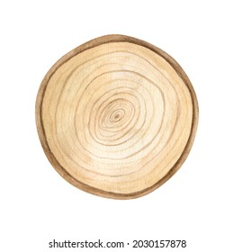
Child’s name:

Relational Mapping activity:
On the tree rings diagram, write the name of the child in your care and then write in the names/title (for workers eg case manager, therapist) of the relationships around them. Identify all the relationships the child or young person has around the child. These relationships should include family, carers, friends, services, and others involved with the child or young person. Put the closest relationships nearer to the child and less close, further away
What do you see as the strengths and challenges of this child or young person’s relational network?

Using Rings of Support with the child in the centre, facilitators will support carers to reflect on the rings of support around the child, consider those closer into the child and those further away. This option may be more suitable for foster carers who will likely have more systematic support available to them, however, do encourage them to also reflect on who is within their family that may also be included. Prompt the carers to consider the various types of support, as prompted below.
- Professionals
  - Case managers
  - Child protection
  - Health professionals
  - Respite carers
  - Therapeutic specialist
  - Mentor
  - School
- Family and friends
- Practical – school drop offs, babysitting, respite
- Emotional – debriefing, support, advice

