1: MY STRESS SIGNALS
Think about the signals (symptoms) you notice in yourself when you experience stress.
Write these signals below under the category to which they best match.
COGNITIVE | MY STRESS SIGNALS  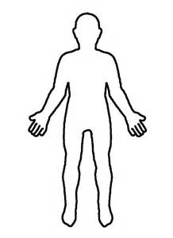 | PHYSICAL
E.g. Memory, concentration, negative thoughts |  | E.g. Headaches, stomach problems, sleep
BEHAVIOURS |  | SELF
E.g. Loss of motivation, contolling or avoidance, unhealthy coping strategies |  | E.g. Reducd confidence, feeling unsatisfied, lack of purpose
RELATIONSHIPS |  | EMOTIONAL
E.g. Withdrawing, increased conflict with others |  | E.g. Anxiety, depression, guilt, irritability

2: MY SELF CARE PRACTICES
Think about the activities and practices you participate in to help reduce stress and maintain wellbeing. Write these into the “Healthy Mind Platter” below under the category to which they best match. Take notice of which categories you do or do not have activities listed at the end.
Focusing on tasks in a goal-oriented way
Unfocused and non-goal directed time; relaxation
Connecting to others and the environment
Quiet internal reflection
Being spontaneous or creative and enjoying new activities
Moving our body
Getting the rest we need

The Healthy Mind Platter is a concept developed by Dr Dan Siegel and Dr David Rock.
https://drdansiegel.com/healthy-mind-platter/
3. MY SELF-CARE PLAN

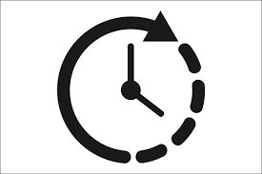 | What are some practices you can do daily to take care of yourself?
 | What are some things you can commit to doing regularly to maintain wellbeing?
 | What self-care do you need to implement when you notice your stress signals becoming a problem?
 | What might get in the way of implementing this plan?
 | What support will you need to overcome these barriers and put this plan into practice? Who can you get this support from?
 | What benefits can you see of putting this plan in place?

