Healthy Mind Platter Coping Strategies
Focus on tasks
& achieve goals
- Get into one of those projects on the to-do list
- Read a book/ newspaper
- Do a Sudoku
- Get crafty
- Housework
Strengthen self by moving
- Go for a walk
- Go to the gym
- Clean the house
- Gardening
Allow our body and
brain to rest
- Go to bed early
- Allow a sleep-in

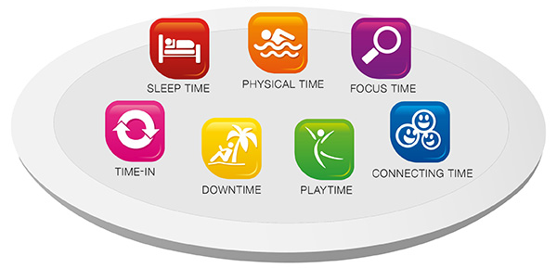
Time for quiet reflection
- Slow down your breathing, take 10 really deep breaths
- Notice… what are 5 things you can see, hear, feel?
- What went well today?
- Reflect on what’s important to you?
- Access your Happy Bag
Let our minds wander
- Watch a favourite movie
- Have a bubble bath
- Appreciate beautiful art
- Sit and soak up nature
Allow spontaneity,
creativity & play
- Dance or sing
- Cook something
- Play a game
- Smile or laugh out loud
Connect with other
people and the world
- Call a friend
- Go out for lunch
- Or dinner or coffee…
- Do something thoughtful
- Go to the beach/ park
- Go sit in nature
- Pray

