Date & Time:
Wednesday 3pm
Start January 1st
For 6 weeks
Venue:
eg. Online or F2F
Overview
A mindful, reflective and respectful parenting program with a focus on building loving and nurturing relationships between parents and carers and their children.
The program supports parents and carers to understand both themselves as parents and their children through the nurturing and supportive environment of the group.
The group offers the opportunity for parents and carers to reflect on their parenting journey and to build a mindful, attuned, nurturing relationships.

Bringing Up Great Kids
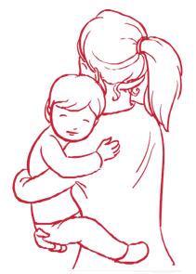
Cost:
$0
Contact:
abc@xyz.com.au
111 111 111
Program Content
The Bringing Up Great Kids program supports parents and carers to:
- Reflect on the origins of their own parenting style and how they would like to parent.
- Consider what is going on in the child’s brain and the relationship to their behaviour.
- Explore communication between parents and children.
- Discover how to overcome some of the obstacles that are getting in the way of being the kind of parent they would like to be.
- Learn about the importance of parents/carers taking care of themselves, to be able to support their children to feel good about themselves.
Insert Logo

